## **Walmart's Overall Customer Satisfaction**

Alyssa Bennett

Phoenix Nguyen

Zainab Olaowo

Paul Taiwo Onyekwuluje

Michael Oppong

Caitlin Pirkle

Nathan Powell

Keino Robinson II

Ryan Sammon

Yasika Sawant

Victoria Schmer

Oliwer Persson Toiminen

Zoie Whitestone

Tonze Yare

*Date*: April 14th, 2024

### **Abstract**

Our research focuses on enhancing customer satisfaction for Walmart Incorporated, a leading retailer, to maintain its competitive advantage in the market. A questionnaire was administered using Likert scales and demographic questions to gather insight into consumers’ perceptions of their Walmart shopping experience.

Using Qualtrics, we developed a comprehensive questionnaire to assess various aspects of the shopping experience. By analyzing 386 responses with SPSS, we derived meaningful insights and recommendations.

Approximately 71% of respondents agree or strongly agree that they are satisfied with the overall shopping experience at Walmart. We were able to delve deeper into what contributes to an enjoyable shopping experience and found that although Walmart performed well in a majority of the areas taken into account, they underperformed compared to their competitors. This led to recommendations that Walmart focus on enhancing these aspects to bolster overall customer satisfaction and perception.

T-tests showed that black or African American respondents demonstrated higher levels of satisfaction with the performance of Walmart compared to white or Caucasian respondents. This is a significant finding for Walmart’s marketing strategy.

Our regression analysis showed that customers' overall satisfaction with their experience at Walmart is heavily dependent on whether or not they are regular shoppers. All of the other variables also had a significant impact on customers’ overall satisfaction, with “Walmart has a welcoming environment for all customers” having the lowest impact. Another regression analysis showed that Walmart customers are likely to recommend the store to their friends and family if they are regular shoppers. Similarly, all variables significantly affect how likely customers are to recommend the store to their friends and family with the welcoming environment having the lowest impact on overall experience.

Some of our recommendations included focusing on enhancing the individual variables that affect the satisfaction of the overall experience like product quality and customer service. Additionally, our team wanted to address the differences between the overall shopping experience for black or African American customers and white or Caucasian customers.

### **Table of Contents**

Introduction ………………………………………………………………………….…………..……..…2

Methodology ………………………………………………………………………………….……..…....3

Analysis ………………………………………………………………..................................................4

Data Summary ……………………………………………………..…………………….….…. 5

Hypothesis Tests or T-Tests ……...……………………………………………………….....34

Tests of One Mean ………………………….……………………….………….34

Tests of Differences Between Means ……..…………………………………..45

Tests of Association ……………………………… ……………………………….…………62

Chi-Square ……………………………………………..………………………..62

Correlations ……………………………………………..…………….. …….….66

Regressions …………………………………………………….……………….70

Conclusions ……………………………………………………………………………………………..77

Recommendations………………………………………………………………………………………80

Limitations ……………………………………………………………………………………………….82

Appendix (or Appendices) ……………………………………………………………………………..84

**Introduction**

Our project aimed to elevate customer satisfaction levels at Walmart, one of the world's largest retail chains. As a cornerstone of the global retail industry, Walmart has continually strived to provide exceptional service and value to its customers. However, in today's dynamic and competitive marketplace, the quest for excellence is ongoing, and there is always room for improvement.

Our project is driven by a deep commitment to understanding and meeting the diverse needs of Walmart's customers. By identifying areas for enhancement and implementing targeted strategies, we aim to not only meet but exceed customer expectations, fostering loyalty and driving sustained business growth.

In this project, we outlined a comprehensive approach to improving the overall customer satisfaction at Walmart. We explored key areas such as customer experience analysis, operational efficiency, employee engagement, and technological innovation to figure out the areas in which Walmart performed well and poorly. We did this by collecting 386 responses from a convenience sample. We used Qualtrics for our survey questions and analyzed the data that we collected by using SPSS. These tools allowed us to assess Walmart’s performance and make accurate conclusions about the different ways that Walmart can improve customer satisfaction.

**Methodology**

Our research began with a questionnaire that was first drafted within Google Docs. The questionnaire consisted of thirteen questions of numerous types: four demographic questions such as age, race, gender, and income, three questions that simply asked about their preferences, distance, and total spent at Walmart on average, and six Likert questions, with many sub-parts, on the topic of pricing, product options, customer service, product quality, curbside pickup, and their online shopping experience. Please see the Appendix for the entire survey.

After completing the questionnaire, it was then coded into Qualtrics. An anonymous link was then sent through email, text, and social media channels, and was administered to friends, family, staff, and faculty within the Richards College of Business. We received 386 valid responses by the end of the survey.

### **Analysis**

We conducted a comprehensive analysis of 386 responses using the Statistical Package for the Social Sciences (SPSS) to gain insights into customer satisfaction levels at Walmart and Target. To be more precise, this Analysis section is organized into the following sub-sections.

1. Data Summary
2. Hypothesis Tests or T-Tests of: (i) One Mean and (ii) Differences Between Means
3. Tests of Association: (i) Chi-Square tests, (ii) Correlations, and (iii) Regression Analysis

### **Data Summary Page for Likert Variables**

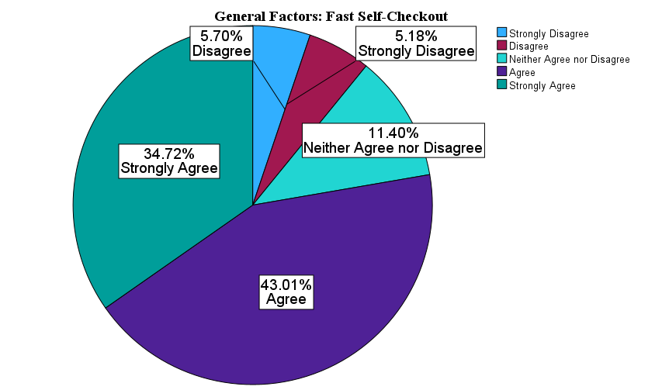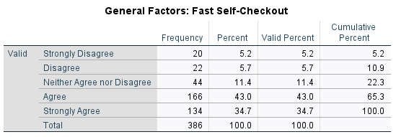

The data shows that most respondents have a positive outlook on fast self-checkout options at the stores they choose to be customers. Those who responded agree or strongly agree make up a total of 77.73% of respondents.

Furthermore, the average response on a 5-point scale, 1 being strongly disagree and 5 being strongly agree, was 3.96. This tells us that the 386-sample size places a high value on the self-checkout options at stores. This high mean is consistent with the high percentage of respondents who Agreed or Strongly Agreed.

**Managerial Conclusion:** Based on our data, we can conclude that our respondents place much value in the self-checkout capabilities of the stores they are shopping at. With 77.73% of the respondents agreeing or strongly agreeing with this statement, it is important to note this important factor when analyzing the variables that can help Walmart outpace its competition.

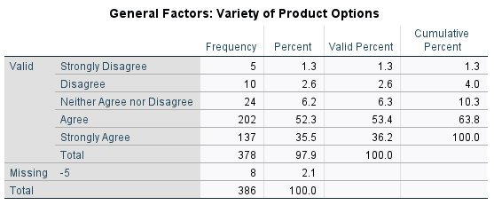

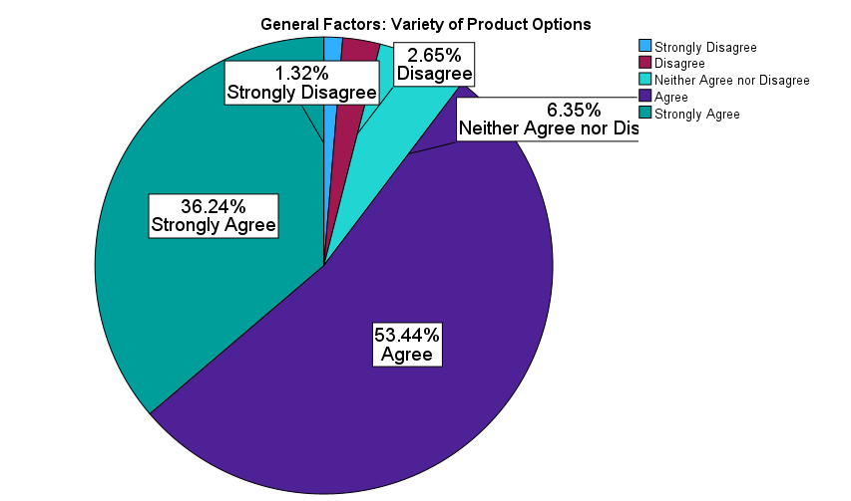

The data shows that a majority of respondents have a positive outlook on the variety of product options that a store holds at any given time. Those who responded agree or strongly agree make up a total of 89.68% of respondents.

Furthermore, the average response on a 5-point scale, 1 being strongly disagree and 5 being strongly agree, was 4.21. This tells us that the 386-sample size values a store that can provide various product options. This very high mean is consistent with the very high percentage of respondents who Agreed or Strongly Agreed.

**Managerial Conclusion:** Because the mean is extremely high for this general factor variable, it is important to note this when looking at ways that Walmart can outperform Target. To create a sustainable competitive advantage, Walmart should provide various options for their customers to keep them happy.

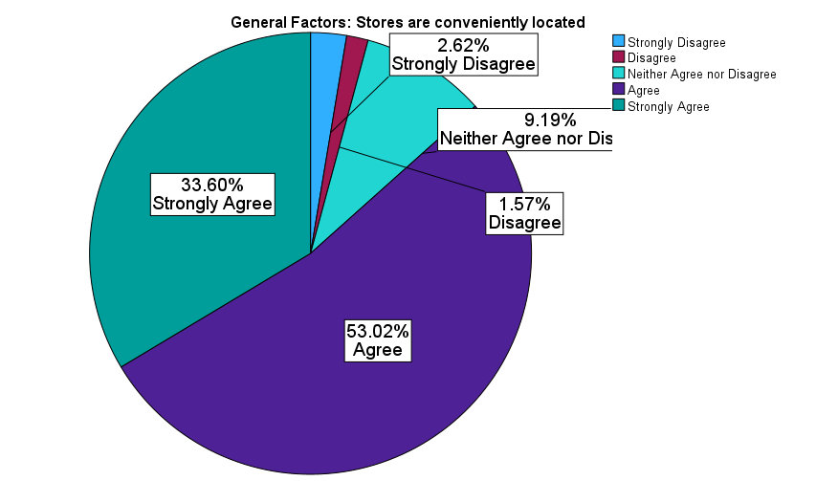

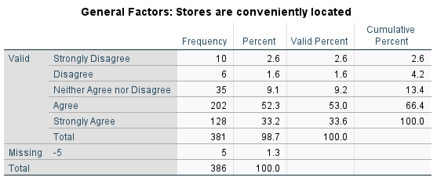The data shows that 86.62% of respondents either agree or strongly agree that they value when stores are placed conveniently around them. Out of the 386 total respondents, only 4.19% either strongly disagreed or disagreed.

Furthermore, the average response on a 5-point scale, 1 being strongly disagree and 5 being strongly agree, was 4.13. This tells us that the 386-sample size has a very positive view of the convenient location of Walmart stores. This high mean is consistent with the high percentage of respondents who Agreed or Strongly Agreed.

**Managerial Conclusion:** Because the mean for this general variable is high, we recommend that Walmart should continue to strategically place its stores nearby so that customers can conveniently access them. To further increase accessibility, we also recommend that Walmart expand into more rural areas of the United States.

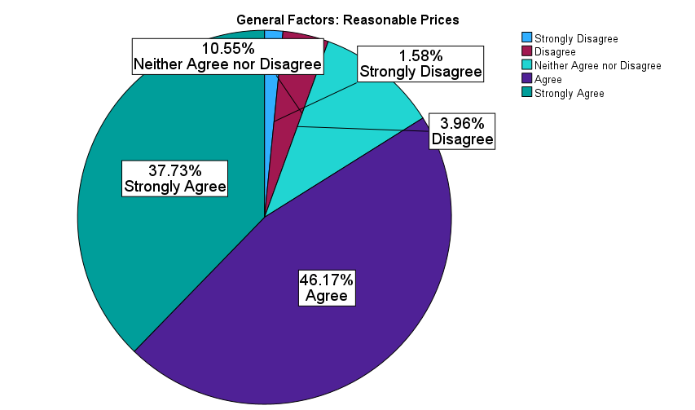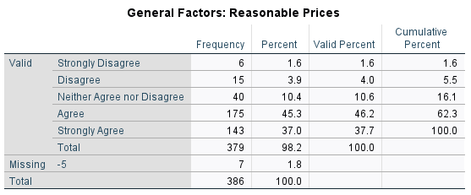

The data shows that a majority of respondents favor reasonable prices. According to the data, 83.9% agree or strongly agree that prices are reasonable, on the other hand, only 5.54% disagree or strongly disagree with this statement.

Furthermore, the average response on a 5-point scale, 1 being strongly disagree and 5 being strongly agree, was 4.15. This tells us that the 386 respondents value the pricing model that different stores hold. This very high mean is consistent with the high percentage of respondents who Agreed or Strongly Agreed.

**Managerial Conclusion:** We recommend that Walmart emphasize its prices to align with the values that our respondents hold. With a mean of 4.15, we can conclude that this is an extremely important variable to customers.

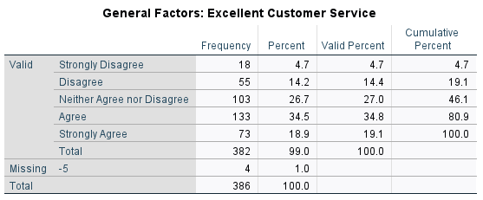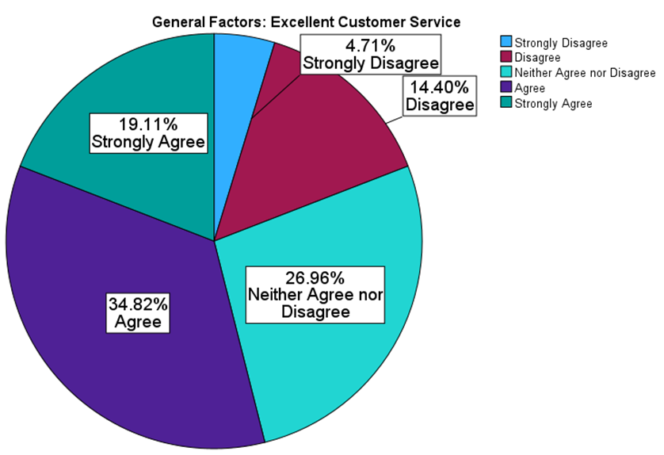The data shows that respondents have a mediocre outlook on customer service at the stores they shop at. According to the data, only 53.93% agree or strongly agree that excellent customer service is a general variable that they value when shopping at different stores.

Furthermore, the average response on a 5-point scale, 1 being strongly disagree and 5 being strongly agree, was 3.49. The mean of 3.49 is just a little above average which is consistent with the 53.93% of respondents who Agreed or Strongly Agreed with this statement.

**Managerial Conclusion:** Customer service is not the most important factor in the eyes of customers, as we can see through the mean of 3.49. In comparison to other variables such as reasonable prices and convenient locations, both had means above 4.0. With this in mind, we can place less emphasis on Walmart’s customer service and focus more on the variables that customers value more.

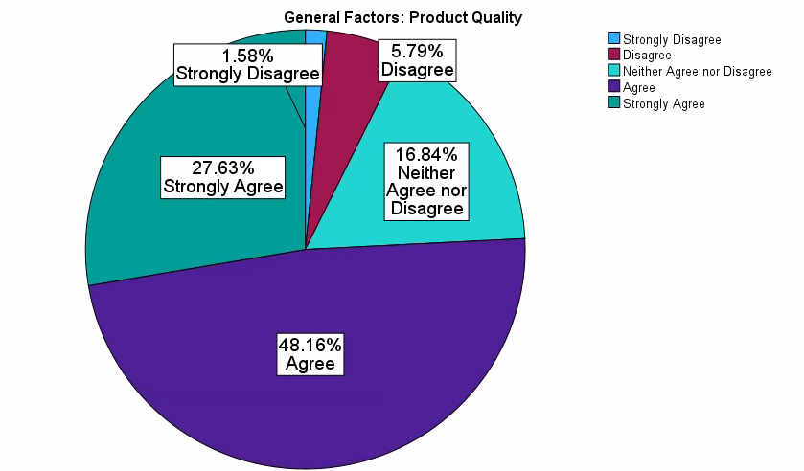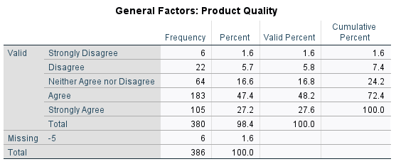

The data shows that most respondents have a positive outlook on the fast self-checkout option at Walmart. Those who responded agree or strongly agree make up a total of 75.79% of respondents.

Furthermore, the average response on a 5-point scale, 1 being strongly disagree and 5 being strongly agree, was 3.94. This tells us that the 386-sample size has a positive view of the self-checkout option at Walmart. This high mean is consistent with the high percentage of respondents who Agreed or Strongly Agreed.

**Managerial Conclusion:** Overall the respondents highly prioritize product quality, so we recommend that Walmart emphasize this in their stores. If Walmart can make their products higher quality, then they have a better chance of a high customer satisfaction score.

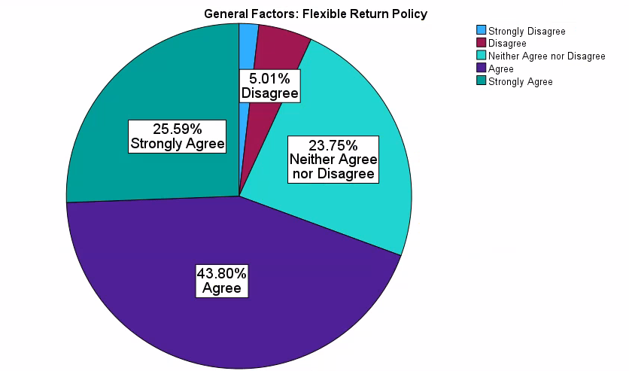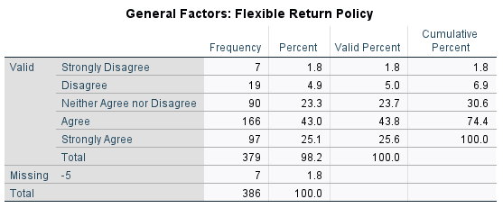

The data shows that about two-thirds of the sample has a positive outlook on stores having a flexible return policy. According to the data, 69.39% agree or strongly agree with that statement, while only 6.86% disagree or strongly disagree with it.

Furthermore, the average response on a 5-point scale, 1 being strongly disagree and 5 being strongly agree, was 3.86. This tells us that the 386-sample size has a favorable view of the self-checkout option at Walmart. This high mean is consistent with the high percentage of respondents who Agreed or Strongly Agreed.

**Managerial Conclusion:** Because our sample prioritizes stores having a flexible return policy, we recommend that Walmart prioritize this in their business to lead to a high overall customer satisfaction score return policy.

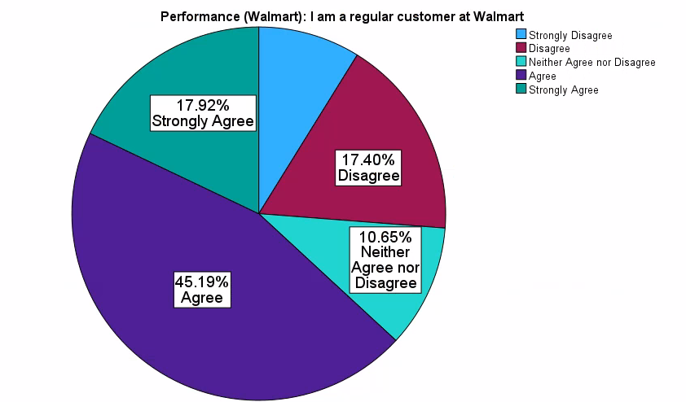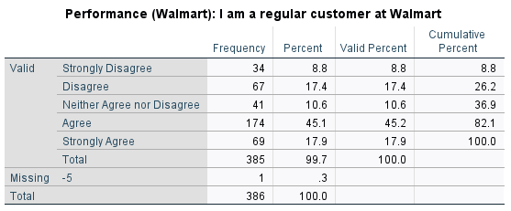The data illustrates that the majority of respondents agreed to be consistent customers at Walmart. Those who responded agree or strongly agree make up a total of 63.11% of respondents. Additionally, only 8.83% of respondents strongly disagree that they shop at Walmart frequently.

The mean for this variable is 3.46 on a 5-point scale, which is consistent with the positive, but not great, percentages shown in the preceding point. Walmart should try to improve the rating to at least 4.0.

**Managerial Conclusion:** We recommend that Walmart seeks to improve its customer experience, for them to gain more regular customers. To improve their customer experience, we recommend that they utilize surveys at their locations to see what their customers’ common complaints are. 26.23% of the sample either disagreed or strongly disagreed, so if Walmart can enhance the experience of these customers they could improve the number of regular customers they have.

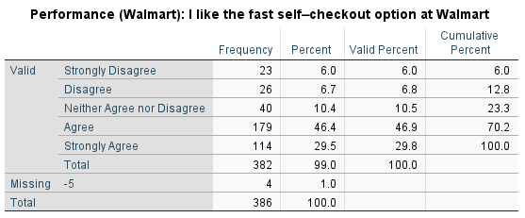

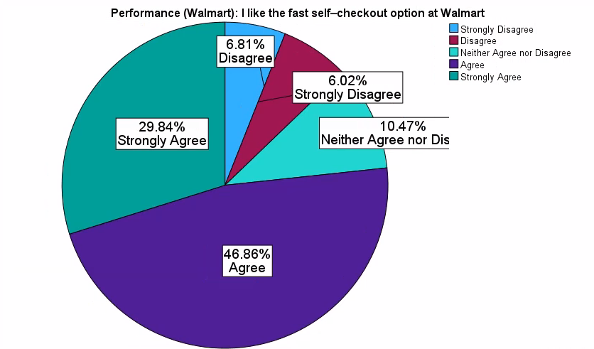

The data shows that a vast majority of respondents have a positive outlook towards Walmart’s fast self-checkout system. Those who responded agree or strongly agree make up a total of 76.7% of respondents.

The mean is 3.88 on a 5-point scale which is close to 4.0 but still has room for improvement. It is consistent with the relatively high percentage (76.7%) of respondents who Agree or Strongly Agree that they like the fast-self-checkout option at Walmart.

**Managerial Conclusion:** We recommend that Walmart seeks to improve its fast-self-checkout option in its stores by providing an easier experience for its customers to purchase their items. To grow in this area, Walmart should target 10.47% of respondents who neither agree nor disagree that Walmart has a fast-self-checkout option.

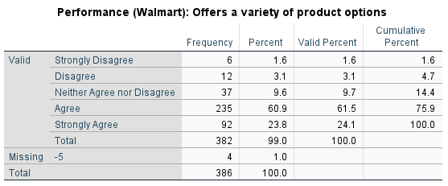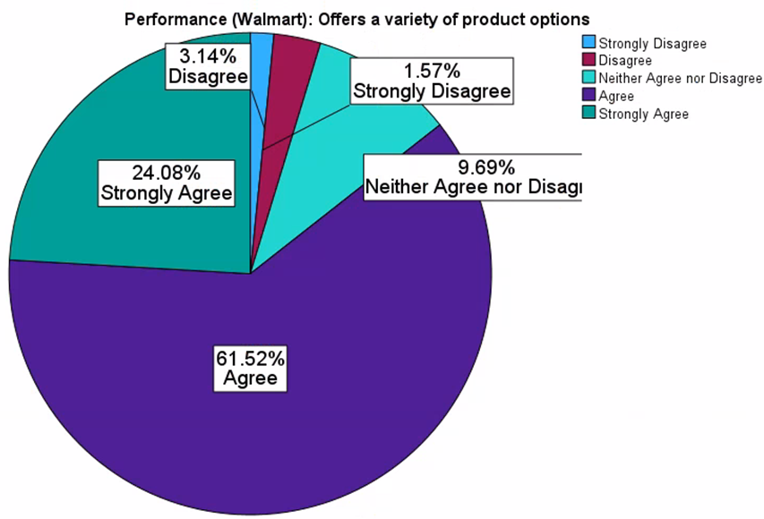

The data shows that most of the sample has a positive view that Walmart offers a variety of product options. Those who responded agree or strongly agree make up a total of 85.6% of respondents.

Furthermore, the average response on a 5-point scale, 1 being strongly disagree and 5 being strongly agree, was 4.03, which fares well for Walmart. This tells us that respondents rate Walmart highly on the variety of options offered. This high mean is consistent with the high percentage of respondents who Agreed or Strongly Agreed.

**Managerial Conclusion:** We recommend that Walmart maintains its current practices when it comes to the variety of options offered. As it stands now, Walmart’s customers are pleased with the number of products they have to choose from.

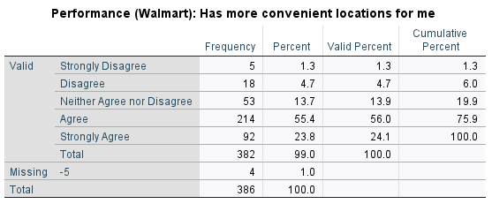

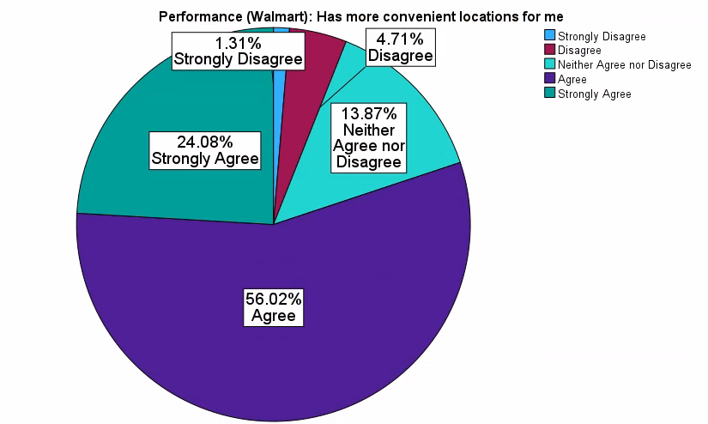

The data shows that most of the sample in the chart has a positive outlook that Walmart provides more convenient locations for their customers. Those who responded agree or strongly agree make up a total of 80.1% of respondents.

Furthermore, the average response on a 5-point scale, 1 being strongly disagree and 5 being strongly agree, was 3.97. This tells us that the sample size believes that Walmart has convenient locations for its customers. This high mean is consistent with the high percentage of respondents who Agreed or Strongly Agreed.

**Managerial Conclusion:** Based on the data indicating the positive attitude of respondents regarding convenient locations, we recommend that Walmart continue to prioritize location convenience, expand accessibility options, and optimize store layouts to streamline the shopping experience.

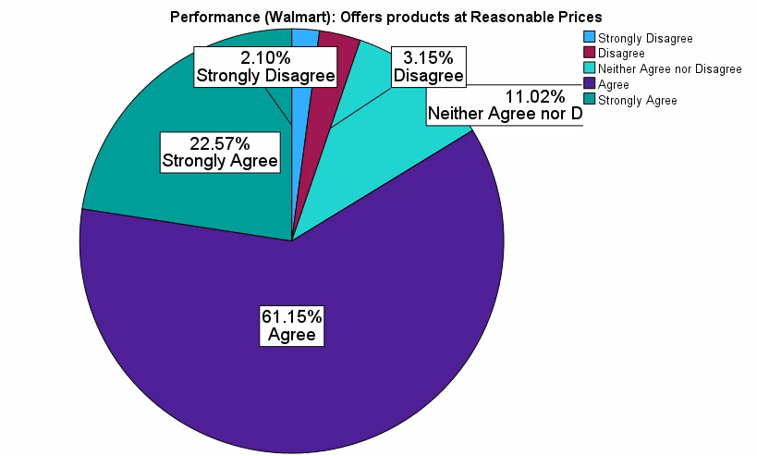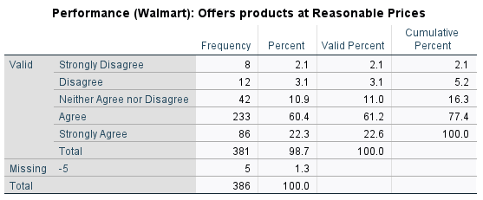The data shows that most of the sample has a positive outlook on Walmart’s reasonable prices. Those who responded agree or strongly agree make up a total of 83.72% of respondents.

Furthermore, the average response on a 5-point scale, 1 being strongly disagree and 5 being strongly agreeing the mean was 3.99. This tells us that the 381-sample size has a positive view of Walmart’s prices. This high mean is consistent with the high percentage of respondents who Agreed or Strongly Agreed.

**Managerial Conclusion:** We recommend that Walmart capitalize on the overwhelmingly positive perception of its prices by strategically leveraging this perception to increase brand loyalty. If Walmart continues to hold its pricing strategy at its core then it will be able to strengthen customer trust.

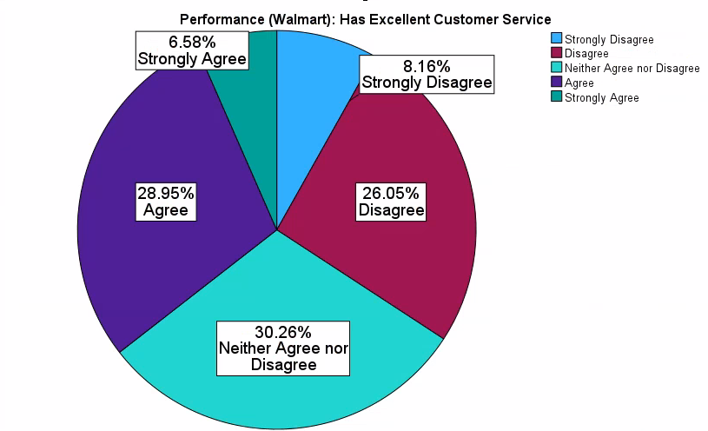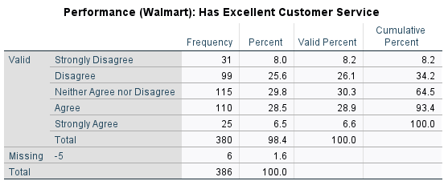The data shows that the sample is mostly neutral about Walmart’s customer service. The data shows that 35.53% of the respondents agree or strongly agree that Walmart has excellent customer service. 34.21% of the respondents disagreed or strongly disagreed with this statement.

Furthermore, the average response on a 5-point scale, 1 being strongly disagree and 5 being strongly agree, was 3.0. This tells us that the 381-sample size has a positive view of Walmart’s prices. This low mean is consistent with the low percentage of respondents who Agreed or Strongly Agreed.

**Managerial Conclusion:** We recommend that Walmart increase their customer’s perception of their customer service by requiring more training for their employees on customer habits. We believe that if Walmart trains their employees on how to better interact with customers then the customers will have a better experience thus a better perception of Walmart’s customer service.

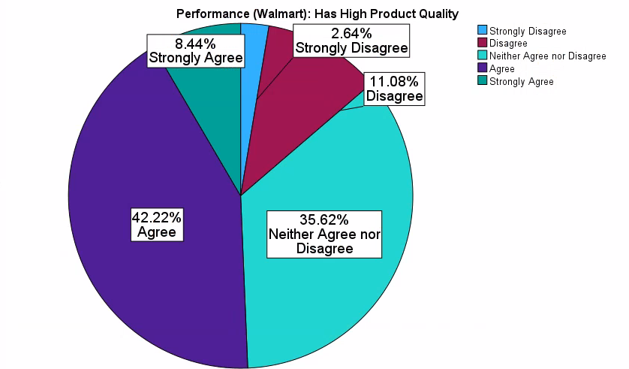

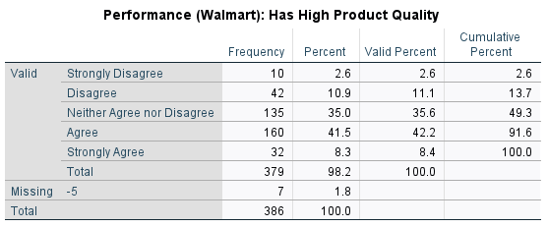The data shows us that the respondents have a semi-favorable view of Walmart’s high product quality.  Those who responded agree or strongly agree made up 50.66% of respondents, where approximately 13.72% either disagreed or strongly disagreed.

Furthermore, the average response on a 5-point scale, 1 being strongly disagree and 5 being strongly agree, was 3.43. Walmart should seek to improve this to at least a 4.0.

**Managerial Conclusion:** We recommend that Walmart perform more quality control checks to meet quality standards before the customers see their products on the shelves. Additionally, Walmart could invest in higher quality materials that would make their products last longer, which could increase their customers’ perception of the brand's quality.

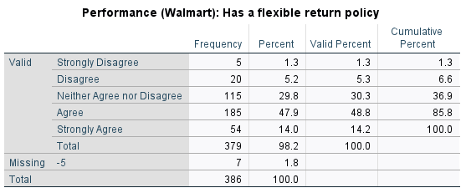

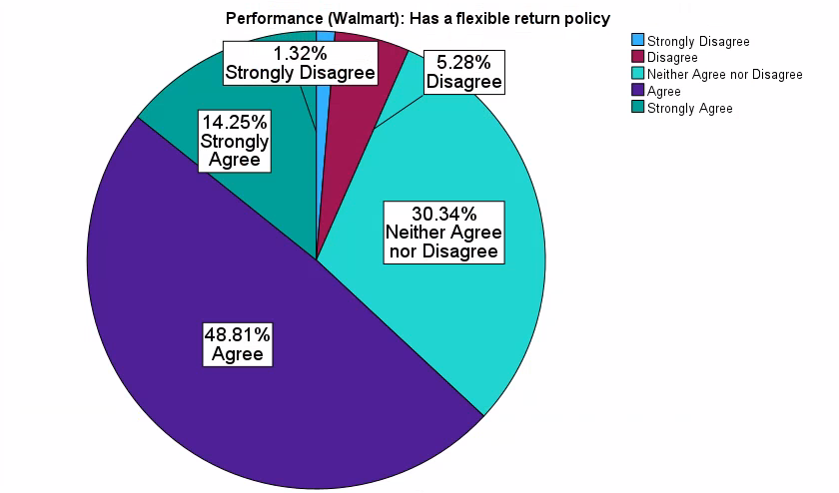

The data in the chart above shows that respondents have a semi-favorable view of Walmart’s return policy. Those who agree or strongly agree make up 61.06% of all respondents in comparison to the 6.60% who either disagreed or strongly disagreed.

Furthermore, the average response on a 5-point scale, 1 being strongly disagree and 5 being strongly agree, was 3.69. Ideally, there is room for improvement here, and Walmart should seek to increase this to at least 4.0.

**Managerial Conclusion:** We recommend that Walmart educate its customers about its return policy to create more favorable perceptions. Only 6.60% of respondents disagree or strongly disagree, which shows that there is not an extremely negative aura around their current policy. However, 30.34% of respondents neither agree nor disagree which could indicate a lack of education concerning their policy.

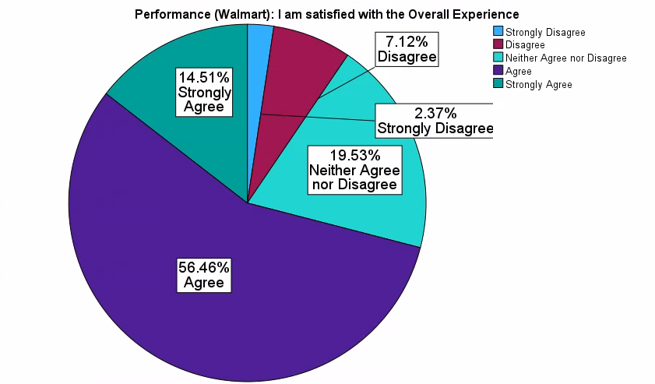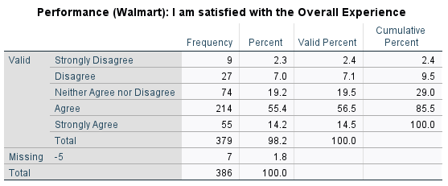

The data shows that more than half of the sample agreed with having a positive overall experience shopping at Walmart. The respondents who completed the survey and agreed or strongly agreed made up 70.97% of the data.

Furthermore, the average response on a 5-point scale, 1 being strongly disagree and 5 being strongly agree, was 3.74. This tells us that the 379-sample size has a somewhat positive view of their overall experience at Walmart. Ideally, Walmart should increase its average to 4.0 through managerial decisions.

**Managerial Conclusion:** We recommend that Walmart adds more value to their customer’s experiences by having more product demonstrations in store. This could enrich their shopper’s experience by giving them more product details and education. Additionally, this could lead to increased satisfaction with the products that each customer buys because they would have already tried them in the stores before bringing their product.

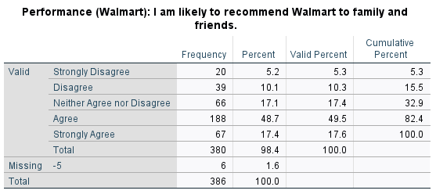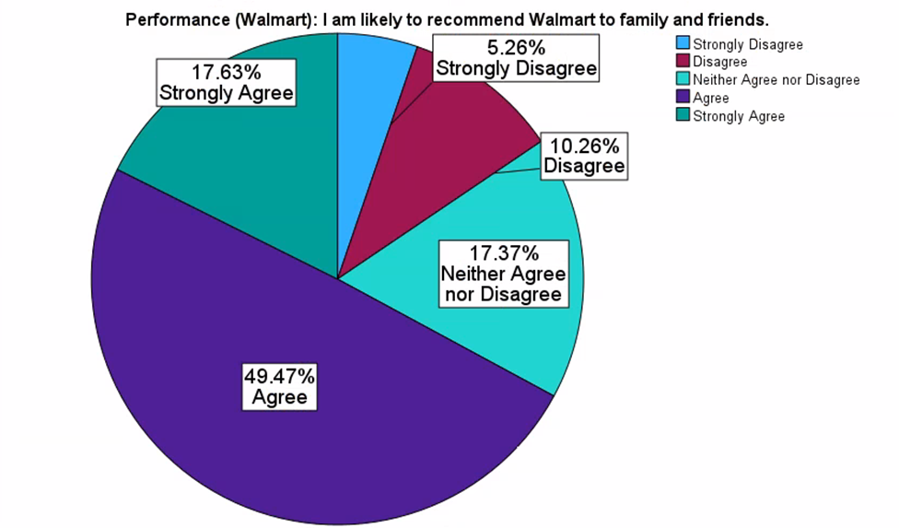

The data chart above shows that the respondents are likely to recommend Walmart to family and friends, as 67.1% agreed or strongly agreed. Approximately 15.52% of respondents either disagreed or strongly disagreed.

Furthermore, the average response on a 5-point scale, 1 being strongly disagree and 5 being strongly agree, was 3.64. This tells us that out of the 380 respondents, about a third of them think positively about Walmart overall.

**Managerial Conclusion:** We recommend that Walmart targets the neither agree nor disagree group, which made up 17.37% of the respondents. This group can increase the mean for this variable. To shift this group's perception, Walmart could incentivize referrals, deliver better customer service in their stores, and publicly encourage online reviews.

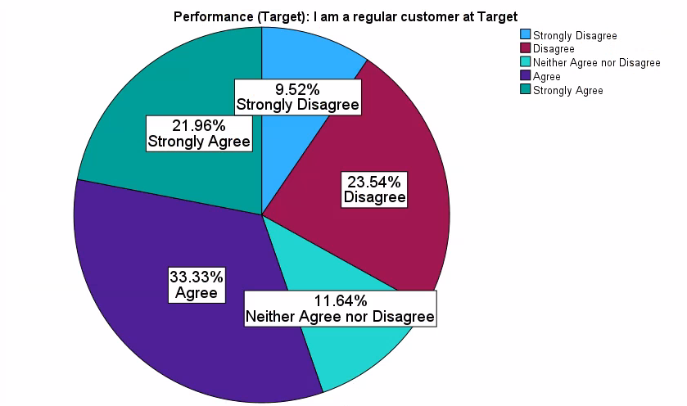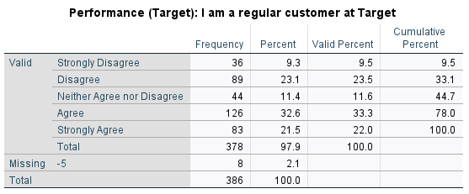The data above shows that customers are mostly neutral when it comes to being a regular customer at Target. Out of the respondents, 55.29% either agreed or strongly agreed that they were regular customers at Target. This is lower than Walmart’s 63.11% who agreed or strongly agreed.

Furthermore, the average response on a 5-point scale, 1 being strongly disagree and 5 being strongly agree, was 3.35. This mean is not spectacular for Target and is very average overall. Ideally, Target wants to aim for a mean of at least 4.0 to outrank Walmart in the eyes of our respondents.

**Managerial Conclusion:** Walmart is outpacing Target when it comes to the number of regular customers. The percentage of respondents who are regular customers at Walmart was 7.82% higher than Target. To maintain this, Walmart needs to create more loyal customers by personalizing their shopper’s experiences, listening to their customers, and staying relevant with the competition.

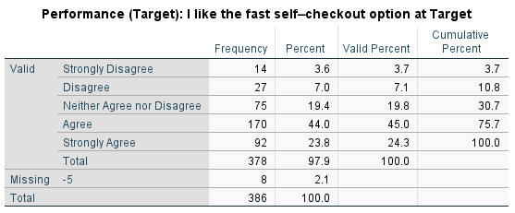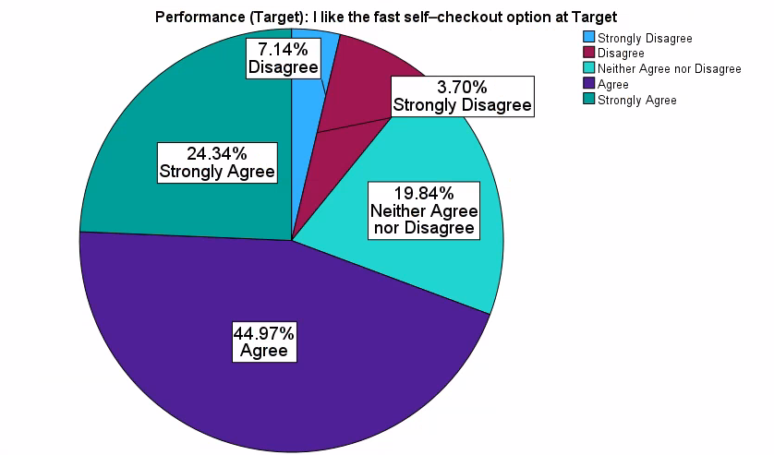

The data table above shows that 69.31% percent of respondents agree or strongly agree that Target has fast self-checkout lines. In comparison, more than 76.7% percent of respondents agreed or strongly agreed that Walmart had fast and convenient self-checkout lines.

Furthermore, the average response on a 5-point scale, 1 being strongly disagree and 5 being strongly agree, was 3.79. This tells us that Target fares moderately well in terms of its fast-self-checkout lanes with our respondents.

**Managerial Conclusion:** Walmart is ahead of the competition in this area but not by a substantial margin. They should continue to invest resources to add additional and improve existing self-checkout lines to keep this advantage over their competitors in the market.

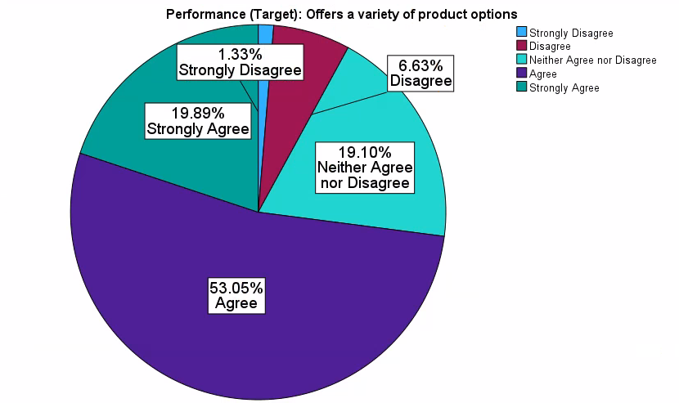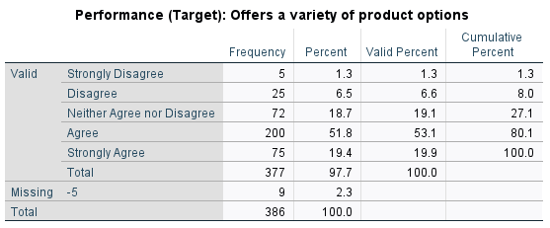

The data table above shows that 72.94% of respondents either agree or strongly agree that Target offers a variety of product options. In comparison, 85.6% of respondents agreed or strongly agreed that Walmart had a variety of product options.

Furthermore, the average response on a 5-point scale, 1 being strongly disagree and 5 being strongly agree, was 3.84. This is a semi-high mean for Target, but overall lower than Walmart’s 4.03.

**Managerial Conclusion:** Walmart is doing well compared to the competition based on respondents from the survey on the diversification of their product line. They do not need to take any drastic measures but need to continue to focus on their product line variety, so this can distinguish them from other competitors in the market.

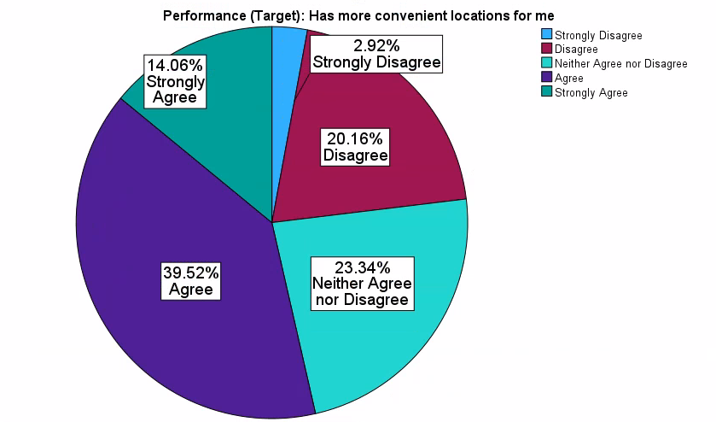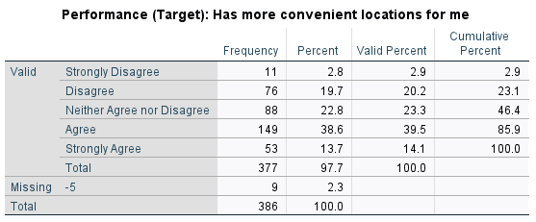

The data table above shows that respondents have a semi-positive view of Target’s store locations. The percentage of respondents who either agreed or strongly agreed was 53.58%.

Furthermore, the average response on a 5-point scale, 1 being strongly disagree and 5 being strongly agree, was 3.42. This is lower than Walmart’s mean of 3.97 which shows that overall Walmart has more convenient locations than Target.

**Managerial Conclusion:** Walmart is outpacing Target in our respondent’s eyes when it comes to convenient locations. Walmart has a mean of 3.97 versus Target’s 3.42 which shows that Walmart has a slightly more favorable position in this variable. We recommend that Walmart conduct more R&D for locations for their customers so they can create a steeper advantage.

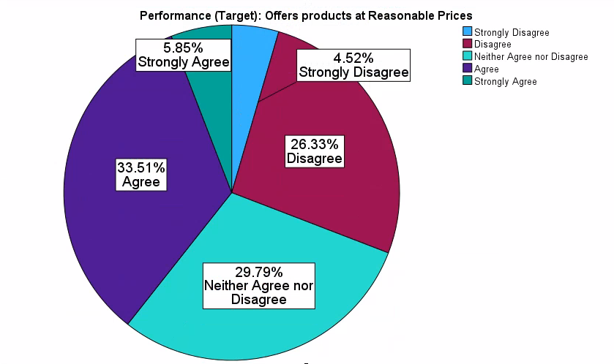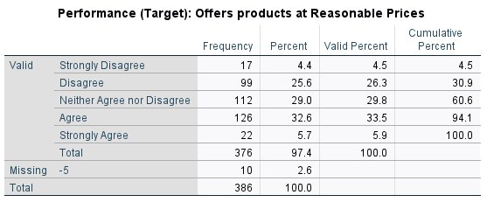

The data table above shows that customers have a semi-neutral position when it comes to Target’s price points. Over half of the respondents are either neutral or disagree that Target has reasonable prices. The number of respondents who either agreed or strongly agreed only made up 39.36% of our sample size as opposed to Walmart’s 83.72%.

Furthermore, the average response on a 5-point scale, 1 being strongly disagree and 5 being strongly agree, was 3.10. This is a poor score for Target which benefits Walmart in the long run. The low mean corresponds to the number of respondents who disagreed.

**Managerial Conclusion:** Walmart has a significant advantage over Target when it comes to its prices. Walmart should continue its current pricing strategy as they are outpacing its competition by a mile.

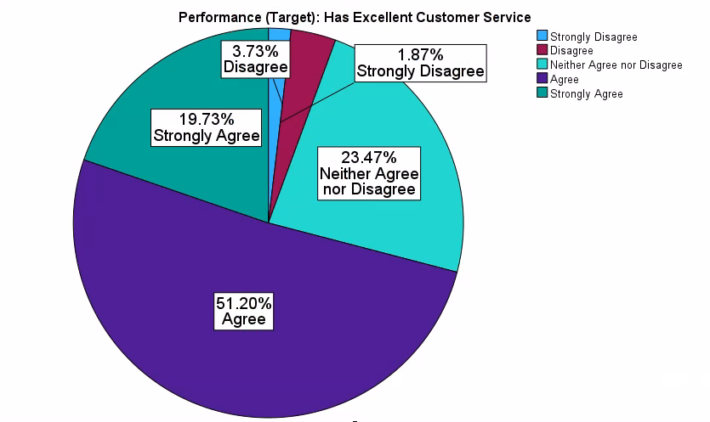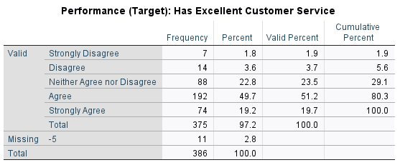

From the data above, we can see that respondents have a positive outlook on Target’s customer service. customer service. Out of our sample size, 70.93% of respondents either agree or strongly agree that Target has excellent customer service.

Furthermore, the average response on a 5-point scale, 1 being strongly disagree and 5 being strongly agree, was 3.83. This high mean is consistent with the high percentage of respondents who Agreed or Strongly Agreed.

**Managerial Conclusion:** Target’s customer service has a more favorable perception than Walmart's, so Walmart must find ways to change their customers’ perception of their current customer service. 70.93% of respondents had a favorable view of Target’s customer service, while Walmart only had 35.53%. We recommend that Walmart trains its employees more in this area to provide customers with a better experience than Target.

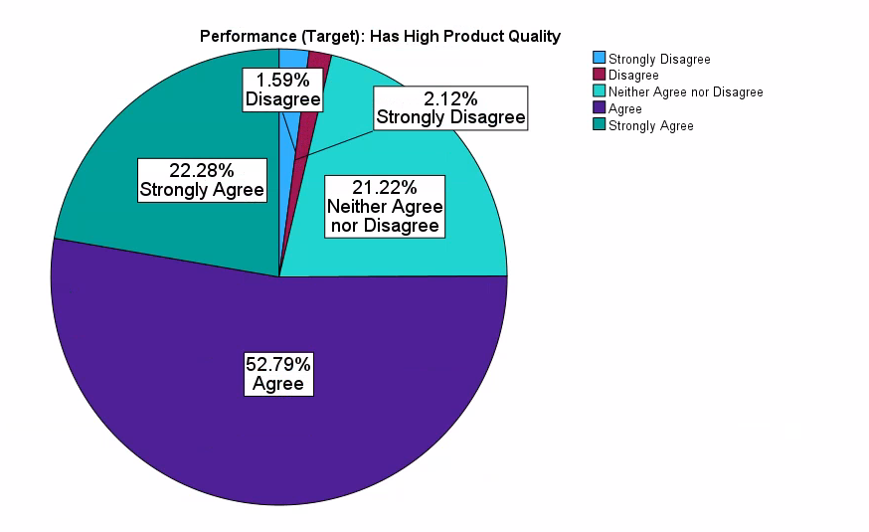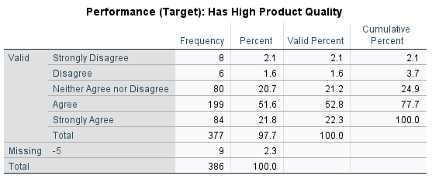The data table above shows that respondents have a positive attitude towards Target’s product quality. Out of our sample, 75.07% either agreed or strongly agreed that Target has high product quality.

Furthermore, the average response on a 5-point scale, 1 being strongly disagree and 5 being strongly agree, was 3.92. This high mean is consistent with the high percentage of respondents who Agreed or Strongly Agreed.

**Managerial Conclusion:** We recommend that Walmart add in higher quality product lines at a more premium price point to provide their customers with more options with better quality. Target edges Walmart in this category as 75.07% of respondents believe that Target’s products are high quality versus Walmart’s 50.66%.

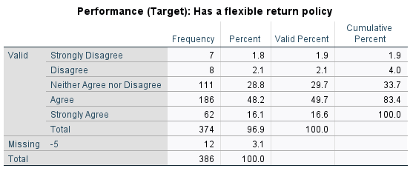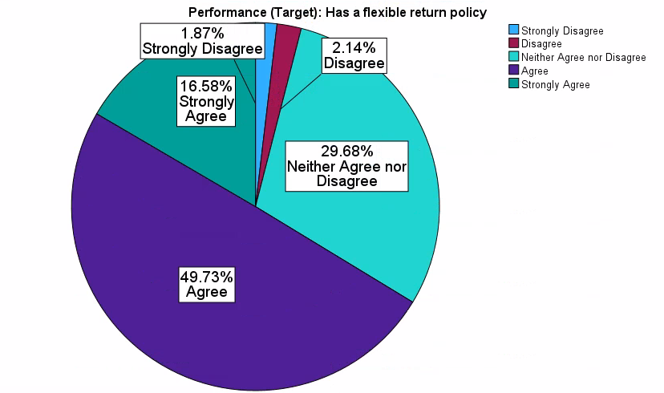

The data shows that the majority of the sample has a positive outlook on the return policy of Target. Those who responded agree or strongly agree make up a total of 66.31% of respondents.

Furthermore, the average response on a 5-point scale, 1 being strongly disagree and 5 being strongly agree, was 3.77. Walmart’s result for this variable is 61.06%, this shows that Target’s has a slightly more flexible return policy than Walmart.

**Managerial Conclusion:** We recommend that Walmart try to develop a more flexible return policy so that customers are more comfortable with buying from them and will likely recommend them. Additionally, we believe that Walmart should educate its customers more on their return policy so that customers feel knowledgeable about the topic.

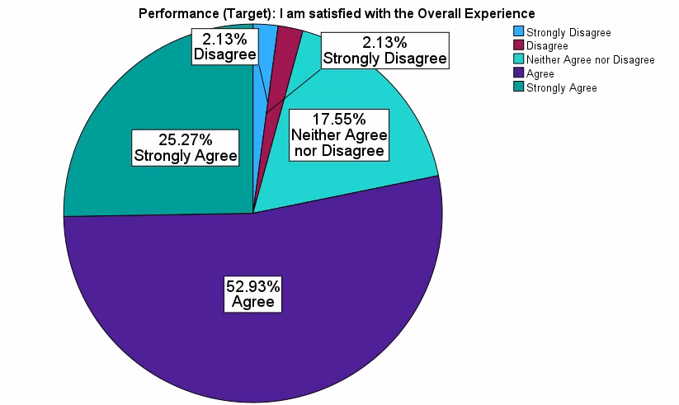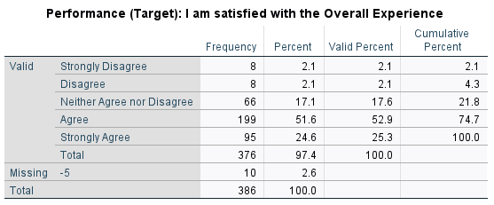

The data shows that most of the sample has a positive outlook on the overall experience at Target. Those who responded agree or strongly agree make up a total of 78.2% of respondents.

Furthermore, the average response on a 5-point scale, 1 being strongly disagree and 5 being strongly agree, was 3.97. This high mean is consistent with the high percentage of respondents who Agreed or Strongly Agreed.

**Managerial Conclusion:** We recommend that Walmart try and increase its overall performance through aesthetics and comfort while shopping to compete more with Target. 78.2% of respondents are satisfied with their shopping experience at Target opposed to 70.97% with Walmart.

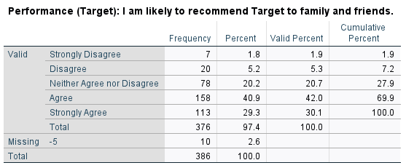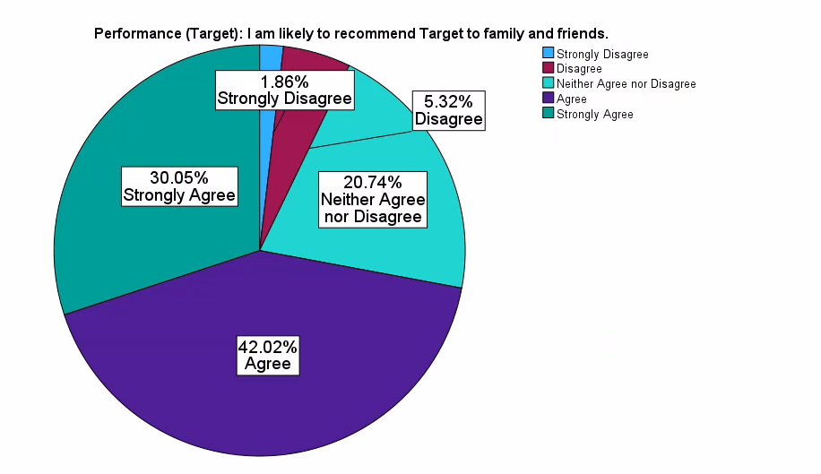

The data table above shows that respondents have a favorable view of Target. Out of our 376-sample size, 72.07% either agreed or strongly agreed that they would recommend Target to family or friends.

Furthermore, the average response on a 5-point scale, 1 being strongly disagree and 5 being strongly agree, was 3.93. This high mean is consistent with the high percentage of respondents who Agreed or Strongly Agreed.

**Managerial Conclusion:** We recommend that Walmart increase its customer service and engage more with its community so that its customers will recommend them more. The percentage of respondents who would recommend Target is 72.07% versus Walmart’s 67.1%. We want to encourage Walmart to boost their customers' experiences while shopping so that they can increase their recommendation percentage.

**General Factors**

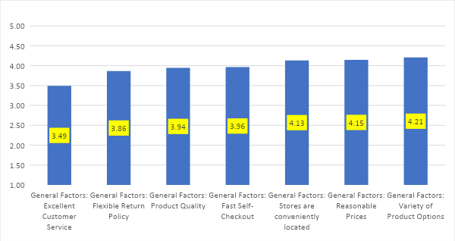

Before examining the overall customer satisfaction for Walmart, we wanted to first look at the variables that customers prioritize the most when shopping at their retailer of choice. This data table summarizes the average means for the overall importance of each relevant factor (what we have called, “general factors”) when our respondents are shopping. This data set showed us that consumers value a variety of product options the most and excellent customer service the least.

T-tests of one mean (one-sample t-tests) showed that Variety of Product Options, Reasonable Prices, and Convenient Locations, had means significantly greater than 4 on a 5-point scale, which clearly means that these are very important factors in the choice of a store, closely followed by Fast Self-Checkout and Product Quality with means insignificantly different from 4.

**Managerial Conclusion:** With this information, Walmart should continue to prioritize its variety of product options, reasonable prices, and convenient locations as these were the top 3 variables the respondents said were most important to them. These general factors gave us direct insight into what consumers want the most, and Walmart should utilize this information to stay on top of consumers' biggest desires.

**T-Test**

*Population Demographics*

Note: We used UWG demographics for testing because our sample was drawn from the UWG student population. The data is as follows;

UWG Population - Female: 63.9 percent; Male: 36.1 percent

Walmart Sample Population - Female: 64.8 percent; Male: 35.2 percent

**Hypothesis test of the Proportion of Females:**  
 Step 1. Ho: P = Po; Ha: P ≠ Po (Po is the proportion of females in the UWG)

Ho: P = 0.639

Ha: P ≠ 0.639

Step 2.

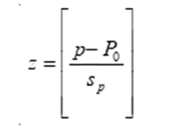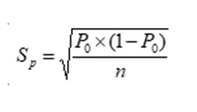

P = 0.648  
Po= 0.639

N = 381

Sp = 0.639*(1-0.639)/381 = 0.0246

Step 3. zt from table = ± 1.96 (using the α = 0.05)  
  
Step 4: Using the formula in step 2, zc = 0.648 - 0.639/0.0246

zc  = 0.366 falling in the fail-to-reject region.

Step 5: **Therefore, we Fail to Reject Ho**, and conclude that our sample proportion of females **is insignificantly different from the population proportion of females in UWG**. This means that our sample is not inconsistent with that of the University of West Georgia population in terms of Gender.

**Hypothesis Testing**

*Test of One Mean*

General Factors

|  |  |
| --- | --- |
|  | Mean |
| General Factors: Fast Self-Checkout | 3.96 |
| General Factors: Variety of Product Options | 4.21 |
| General Factors: Stores are conveniently located | 4.13 |
| General Factors: Reasonable Prices | 4.15 |
| General Factors: Excellent Customer Service | 3.49 |
| General Factors: Product Quality | 3.94 |
| General Factors: Flexible Return Policy | 3.86 |

|  |  |  |  |
| --- | --- | --- | --- |
| Test Value = 3 | t | df | Sig. (2-tailed) |
| General Factors: Fast Self-Checkout | 17.602 | 385 | <.001 |
| General Factors: Variety of Product Options | 30.034 | 377 | <.001 |
| General Factors: Stores are conveniently located | 26.248 | 380 | <.001 |
| General Factors: Reasonable Prices | 25.495 | 378 | <.001 |
| General Factors: Excellent Customer Service | 8.759 | 381 | <.001 |
| General Factors: Product Quality | 20.368 | 379 | <.001 |
| General Factors: Flexible Return Policy | 18.288 | 378 | <.001 |

The Sig (2-tailed) is < 0.05 for all the following variables (Fast Self-Checkout, Variety of Product Options, Conveniently Located Stores, Reasonable Prices, Excellent Customer Service, Product Quality, Flexible Return Policy). This means the results are statistically significant. Additionally, because the t-score is positive, it proves that the mean is greater than the test value chosen (3). These results mean that all the variables mentioned above had a strong influence on a customer's satisfaction with their shopping experience. Because of these findings, we reject the null hypothesis.

|  |  |  |  |
| --- | --- | --- | --- |
| Test Value = 4 | t | df | Sig. (2-tailed) |
| General Factors: Fast Self-Checkout | -0.662 | 385 | 0.508 |
| General Factors: Variety of Product Options | 5.137 | 377 | <.001 |
| General Factors: Stores are conveniently located | 3.099 | 380 | 0.002 |
| General Factors: Reasonable Prices | 3.231 | 378 | 0.001 |
| General Factors: Excellent Customer Service | -9.039 | 381 | <.001 |
| General Factors: Product Quality | -1.191 | 379 | 0.234 |
| General Factors: Flexible Return Policy | -2.908 | 378 | 0.004 |

The Sig (2-tailed) is < 0.05 for all the following variables (Variety of Product Options, Stores are conveniently located, Excellent Customer Service, and Flexible Return Policy), this means the results are statistically significant. However, only the t-score for Variety of Product Options and Stores are Conveniently located is positive, meaning the mean is greater than the test value chosen (4). Although the Excellent Customer Service and Flexible Return Policy variables are statistically significant, their t-score is negative. This means that the mean of this variable is significantly less than the test value chosen (4). However, the Sig.(2-tailed) is > 0.05 for the following variables (Fast Self-Checkout and Product Quality), this means that the results are statistically insignificant and we fail to reject the null hypothesis.

**The following variables had means significantly greater than 4:**

General Factors: Reasonable Prices

General Factors: Variety of Product Options

General Factors: Stores are conveniently located

**The following variables had means insignificantly different from 4:**

General Factors: Product Quality

General Factors: Fast Self-Checkout

**The following variables had means significantly less than 4, but significantly greater than 3:**

General Factors: Excellent Customer Service

General Factors: Flexible Return Policy

**The following variables had means insignificantly different from 3:**

None

**The following variables had means significantly less than 3:**

None

**Managerial Conclusion:** Our data collected shows that conveniently located stores, reasonable prices, and diverse product options are the most important factors when consumers are choosing where to shop, followed closely by product quality and fast self-checkout. The manager would be advised to take into consideration these five factors when attempting to create a satisfactory shopping experience.

**Hypothesis Testing**

*Test of One Mean*

Performance (Walmart)

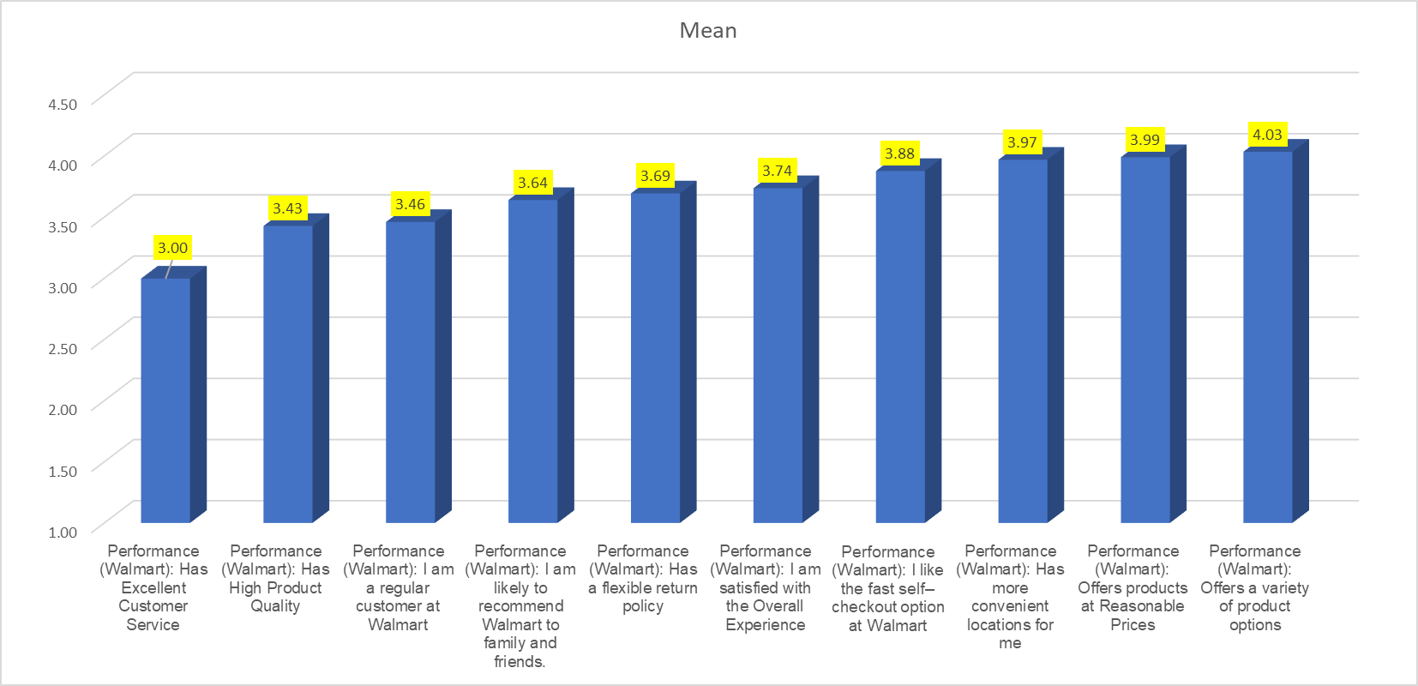

|  |  |
| --- | --- |
|  | Mean |
| Performance (Walmart): I am a regular customer at Walmart | 3.46 |
| Performance (Walmart): I like the fast self–checkout option at Walmart | 3.88 |
| Performance (Walmart): Offers a variety of product options | 4.03 |
| Performance (Walmart): Has more convenient locations for me | 3.97 |
| Performance (Walmart): Offers products at Reasonable Prices | 3.99 |
| Performance (Walmart): Has Excellent Customer Service | 3.00 |
| Performance (Walmart): Has High Product Quality | 3.43 |
| Performance (Walmart): Has a flexible return policy | 3.69 |
| Performance (Walmart): I am satisfied with the Overall Experience | 3.74 |
| Performance (Walmart): I am likely to recommend Walmart to family and friends. | 3.64 |

|  |  |  |  |  |
| --- | --- | --- | --- | --- |
| **Test Value = 3** | t | Significance | |  |
| One-Sided p | Two-Sided p |  |
| Performance (Walmart): I am a regular customer at Walmart | 7.394 | <.001 | <.001 |  |
| Performance (Walmart): I like the fast self–checkout option at Walmart | 15.612 | <.001 | <.001 |  |
| Performance (Walmart): Offers a variety of product options | 25.980 | <.001 | <.001 |  |
| Performance (Walmart): Has more convenient locations for me | 22.845 | <.001 | <.001 |  |
| Performance (Walmart): Offers products at Reasonable Prices | 23.910 | <.001 | <.001 |  |
| Performance (Walmart): Has Excellent Customer Service | -.048 | .481 | .962 |  |
| Performance (Walmart): Has High Product Quality | 9.329 | <.001 | <.001 |  |
| Performance (Walmart): Has a flexible return policy | 16.336 | <.001 | <.001 |  |
| Performance (Walmart): I am satisfied with the Overall Experience | 16.316 | <.001 | <.001 |  |
| Performance (Walmart): I am likely to recommend Walmart to family and friends. | 11.847 | <.001 | <.001 |  |

The Sig (2-tailed) is < 0.05 for all the following variables (I am a regular customer at Walmart, I like the fast self–checkout option at Walmart, Offers a variety of product options, Has more convenient locations for me, Offers products at Reasonable Prices, Has High Product Quality, Has a flexible return policy, I am satisfied with the Overall Experience, I am likely to recommend Walmart to family and friends). This means that the result is statistically significant. Further, since t is positive, it means that the mean of the variable is greater than the Test Value chosen (3). So, the combination of these two means that the mean of the variables above is significantly greater than the Test Value chosen (3). Therefore, using the test value of 3, Walmart is doing very well on the referenced variables. However, the Sig (2-tailed) is > 0.05 for “Has Excellent Customer Service”, this means that the result is statistically insignificant. Therefore, we fail to reject the Null hypothesis and conclude that the mean of the variables is equal to 3.

|  |  |  |  |
| --- | --- | --- | --- |
| **Test Value=4** | t | Significance | |
| One-Sided p | Two-Sided p |
| Performance (Walmart): I am a regular customer at Walmart | -8.688 | <.001 | <.001 |
| Performance (Walmart): I like the fast self–checkout option at Walmart | -2.190 | .015 | .029 |
| Performance (Walmart): Offers a variety of product options | .855 | .197 | .393 |
| Performance (Walmart): Has more convenient locations for me | -.741 | .230 | .459 |
| Performance (Walmart): Offers products at Reasonable Prices | -.254 | .400 | .800 |
| Performance (Walmart): Has Excellent Customer Service | -18.286 | <.001 | <.001 |
| Performance (Walmart): Has High Product Quality | -12.496 | <.001 | <.001 |
| Performance (Walmart): Has a flexible return policy | -7.205 | <.001 | <.001 |
| Performance (Walmart): I am satisfied with the Overall Experience | -5.848 | <.001 | <.001 |
| Performance (Walmart): I am likely to recommend Walmart to family and friends. | -6.679 | <.001 | <.001 |

The Sig (2-tailed) is < 0.05 for all the following variables (I am a regular customer at Walmart, I like the fast self–checkout option at Walmart, Has High Product Quality, Has Excellent Customer Service, Has a flexible return policy, I am satisfied with the Overall Experience, I am likely to recommend Walmart to family and friends). This means that the result is statistically significant. Further, since t is negative for these variables, it means that the mean of the variable is lesser than the Test Value chosen (4). So, the combination of these two means that the mean of the variables above is significantly lower than the Test Value chosen (4). Therefore, using the test value of 4, Walmart needs improvement to achieve this desired mean. However, the Sig (2-tailed) is > 0.05 for “Offers a variety of product options, Has more convenient locations for me and Offers products at Reasonable Prices”, this means that the result is statistically insignificant. Therefore, we fail to reject the Null hypothesis and conclude that the mean of the variables is equal to 4.

**Managerial Conclusion:** The results show that most of the sample had a less promising outlook on Walmart’s performance when evaluated on the following variables; I am a regular customer at Walmart, I like the fast self–checkout option at Walmart, Has High Product Quality, Has Excellent Customer Service, Has a flexible return policy, I am satisfied with the Overall Experience, I am likely to recommend Walmart to family and friends, we therefore recommend that needs improvement on these variables. On the other hand, the sample had a positive outlook on variables like; Offers a variety of product options, Has more convenient locations for me, and Offers products at Reasonable Prices, It is therefore recommended that Walmart continues its policies and practices for these variables to build a healthy customer perception.

**The following variables had means significantly greater than 4:**

None

**The following variables had means insignificantly different from 4:**

Offers a variety of product options

Has more convenient locations for me

Offers products at Reasonable Prices

**The following variables had means significantly less than 4, but greater than 3:**

I am a regular customer at Walmart

I like the fast self–checkout option at Walmart

High Product Quality

Has a flexible return policy

I am satisfied with the Overall Experience

I am likely to recommend Walmart to family and friends.

**The following variables had means insignificantly different from 3:**

Has Excellent Customer Service

**The following variables had means significantly less than 3:**

None

**Managerial Conclusion:** Our sample data above shows that customers like fast self-checkout, high product quality, and their flexible return policy which makes them visit Walmart regularly and agree that they are mostly satisfied with their experience and would recommend Walmart to family and friends. These variables are significantly less than 4 but greater than 3.

Further, the data indicates that the mean for the variable “Offers a variety of product options”, “Has more convenient locations for me”, and Offers products at Reasonable Prices are insignificantly different from 4. While Excellent customer service has a mean, which is insignificantly different from 3.

**Hypothesis Testing**

*Test of One Mean*

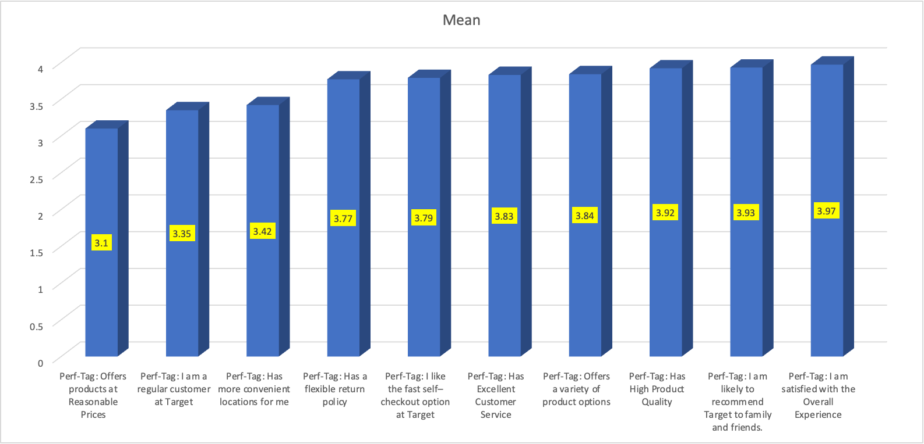Performance (Target)

|  |  |
| --- | --- |
|  | Mean |
| Performance (Target): Offers products at Reasonable Prices | 3.10 |
| Performance (Target): I am a regular customer at Target | 3.35 |
| Performance (Target): Has more convenient locations for me | 3.42 |
| Performance (Target): Has a flexible return policy | 3.77 |
| Performance (Target): I like the fast self–checkout option at Target | 3.79 |
| Performance (Target): Has Excellent Customer Service | 3.83 |
| Performance (Target): Offers a variety of product options | 3.84 |
| Performance (Target): Has High Product Quality | 3.92 |
| Performance (Target): I am likely to recommend Target to family and friends. | 3.93 |
| Performance (Target): I am satisfied with the Overall Experience | 3.97 |

|  |  |  |  |
| --- | --- | --- | --- |
| Test Value = 3 |  | | |
| t | Significance | |
| One-Sided p | Two-Sided p |
| Performance (Target): I am a regular customer at Target | 5.149 | <.001 | <.001 |
| Performance (Target): I like the fast self–checkout option at Target | 15.228 | <.001 | <.001 |
| Performance (Target): Offers a variety of product options | 18.740 | <.001 | <.001 |
| Performance (Target): Has more convenient locations for me | 7.691 | <.001 | <.001 |
| Performance (Target): Offers products at Reasonable Prices | 1.902 | .029 | .058 |
| Performance (Target): Has Excellent Customer Service | 18.948 | <.001 | <.001 |
| Performance (Target): Has High Product Quality | 21.480 | <.001 | <.001 |
| Performance (Target): Has a flexible return policy | 18.255 | <.001 | <.001 |
| Performance (Target): I am satisfied with the Overall Experience | 22.406 | <.001 | <.001 |
| Performance (Target): I am likely to recommend Target to family and friends. | 19.177 | <.001 | <.001 |

The Sig (2-tailed) is < 0.05 for all the following variables (I am a regular customer at Target, I like the fast self–checkout option at Target, Offers a variety of product options, Has more convenient locations for me, Has High Product Quality, Has Excellent Customer Service, Has a flexible return policy, I am satisfied with the Overall Experience, I am likely to recommend Target to family and friends). This means that the result is statistically significant. Further, since t is positive for these variables, it means that the mean of the variable is greater than the Test Value chosen (3). So, the combination of these two means that the mean of the variables above is significantly greater than the Test Value chosen (3). Therefore, using the test value of 3, Target is performing well. However, the Sig (2-tailed) is > 0.05 for “Offers products at Reasonable Prices”, this means that the result is statistically insignificant. Therefore, we fail to reject the null hypothesis and conclude that the mean of the variables is equal to 3.

|  |  |  |  |  |
| --- | --- | --- | --- | --- |
| Test Value = 4 |  | | | |
| t | Significance | |  |
| One-Sided p | Two-Sided p |  |
| Performance (Target): I am a regular customer at Target | -9.708 | <.001 | <.001 |  |
| Performance (Target): I like the fast self–checkout option at Target | -4.024 | <.001 | <.001 |  |
| Performance (Target): Offers a variety of product options | -3.688 | <.001 | <.001 |  |
| Performance (Target): Has more convenient locations for me | -10.777 | <.001 | <.001 |  |
| Performance (Target): Offers products at Reasonable Prices | -17.428 | <.001 | <.001 |  |
| Performance (Target): Has Excellent Customer Service | -3.826 | <.001 | <.001 |  |
| Performance (Target): Has High Product Quality | -1.992 | .024 | .047 |  |
| Performance (Target): Has a flexible return policy | -5.451 | <.001 | <.001 |  |
| Performance (Target): I am satisfied with the Overall Experience | -.675 | .250 | .500 |  |
| Performance (Target): I am likely to recommend Target to family and friends. | -1.425 | .078 | .155 |  |

The Sig (2-tailed) is < 0.05 for all the following variables; I am a regular customer at Target, I like the fast self–checkout option at Target, Offers a variety of product options, Has more convenient locations for me, Offers products at Reasonable Prices, Has High Product Quality, Has Excellent Customer Service, Has a flexible return policy. This means that the result is statistically significant. Further, since t is negative for these variables, it means that the mean of the variable is lesser than the Test Value chosen (4). So, the combination of these two means that the mean of the variables above is significantly lower than the Test Value chosen (4). Therefore, using the test value of 4, Target needs improvement to achieve this desired mean. However, the Sig (2-tailed) is > 0.05 for “I am satisfied with the Overall Experience, I am likely to recommend Target to family and friends”, this means that the result is statistically insignificant. Therefore, we fail to reject the Null hypothesis and conclude that the mean of the variables is equal to 4.

**Managerial Conclusion:** The results show that most of the sample had a less promising outlook on Target’s performance when evaluated on the following variables; I am a regular customer at Target, I like the fast self–checkout option at Target, Offers a variety of product options, Has more convenient locations for me, Offers products at Reasonable Prices, Has High Product Quality, Has Excellent Customer Service, Has a flexible return policy, we therefore recommend that Target needs improvement on these variables. On the other hand, the sample had a positive outlook on variables like; I am satisfied with the Overall Experience, I am likely to recommend Target to family and friends, It is therefore recommended that Target continue its policies and practices for these variables to build a healthy customer perception.

**The following variables had means significantly greater than 4:**

None

**The following variables had means insignificantly different from 4:**

Has High Product Quality

I am satisfied with the Overall Experience

I am likely to recommend Target to family and friends.

**The following variables had means significantly less than 4, but greater than 3:**

I am a regular customer at Target

I like the fast self–checkout option at Target

Offers a variety of product options

Has more convenient locations for me

Has Excellent Customer Service

Has a flexible return policy

**The following variables had means insignificantly different from 3:**

Offers products at Reasonable Prices

**The following variables had means significantly less than 3:**

None

**Hypothesis Testing**

*Test of Differences between Means: (Gender)*

General Factors

|  |  |  |
| --- | --- | --- |
|  | What is your gender? | Mean |
| General Factors: Fast Self-Checkout | Male | 3.96 |
| Female | 3.97 |
| General Factors: Variety of Product Options | Male | 4.16 |
| Female | 4.23 |
| General Factors: Stores are conveniently located | Male | 4.08 |
| Female | 4.16 |
| General Factors: Reasonable Prices | Male | 4.03 |
| Female | 4.21 |
| General Factors: Excellent Customer Service | Male | 3.49 |
| Female | 3.49 |
| General Factors: Product Quality | Male | 3.86 |
| Female | 3.98 |
| General Factors: Flexible Return Policy | Male | 3.82 |
| Female | 3.88 |

|  |  |  |  |  |
| --- | --- | --- | --- | --- |
|  | | t | Significance | |
| One-Sided p | Two-Sided p |
| General Factors: Fast Self-Checkout | Equal variances assumed | -.107 | .457 | .915 |
| Equal variances not assumed | -.107 | .457 | .915 |
| General Factors: Variety of Product Options | Equal variances assumed | -.805 | .211 | .422 |
| Equal variances not assumed | -.793 | .214 | .429 |
| General Factors: Stores are conveniently located | Equal variances assumed | -.804 | .211 | .422 |
| Equal variances not assumed | -.811 | .209 | .418 |
| General Factors: Reasonable Prices | Equal variances assumed | -1.884 | .030 | .060 |
| Equal variances not assumed | -1.778 | .038 | .077 |
| General Factors: Excellent Customer Service | Equal variances assumed | -.009 | .496 | .993 |
| Equal variances not assumed | -.009 | .496 | .993 |
| General Factors: Product Quality | Equal variances assumed | -1.215 | .112 | .225 |
| Equal variances not assumed | -1.179 | .120 | .240 |
| General Factors: Flexible Return Policy | Equal variances assumed | -.609 | .271 | .543 |
| Equal variances not assumed | -.602 | .274 | .547 |

**The following variables showed no significant difference between Males and Females;**

I like the fast self–checkout option at Walmart

Offers a variety of product options

Has more convenient locations for me

Has Excellent Customer Service

Has High Product Quality

Flexible Return Policy

**The following variables showed significantly higher means for Males;**

None

**The following variables showed significantly higher means for Females;**

Has Reasonable Prices

**Managerial Conclusion:** The result showed that there is no significant difference between Males and Females for the majority of the variables examined. However, there were significantly higher means for females for the variable “has reasonable prices”. It is important for Walmart managers to note this factor as many females in the household perform shopping duties, so it is important for them to have reasonable prices.

**Hypothesis Testing**

*Test of Differences between Means: (Gender)*

Performance (Walmart)

|  |  |  |  |
| --- | --- | --- | --- |
|  | What is your gender? | N | Mean |
| Performance (Walmart): I am a regular customer at Walmart | Male | 134 | 3.52 |
| Female | 247 | 3.43 |
| Performance (Walmart): I like the fast self–checkout option at Walmart | Male | 132 | 3.88 |
| Female | 246 | 3.87 |
| Performance (Walmart): Offers a variety of product options | Male | 134 | 3.96 |
| Female | 244 | 4.07 |
| Performance (Walmart): Has more convenient locations for me | Male | 134 | 3.84 |
| Female | 244 | 4.03 |
| Performance (Walmart): Offers products at Reasonable Prices | Male | 133 | 3.82 |
| Female | 244 | 4.08 |
| Performance (Walmart): Has Excellent Customer Service | Male | 133 | 3.11 |
| Female | 243 | 2.91 |
| Performance (Walmart): Has High Product Quality | Male | 133 | 3.39 |
| Female | 242 | 3.43 |
| Performance (Walmart): Has a flexible return policy | Male | 133 | 3.70 |
| Female | 242 | 3.68 |
| Performance (Walmart): I am satisfied with the Overall Experience | Male | 132 | 3.78 |
| Female | 243 | 3.70 |
| Performance (Walmart): I am likely to recommend Walmart to family and friends. | Male | 132 | 3.72 |
| Female | 244 | 3.59 |

|  |  |
| --- | --- |
|  | |
| t | Significance | |
| One-Sided p | Two-Sided p |
| Performance (Walmart): I am a regular customer at Walmart | Equal variances assumed | .714 | .238 | .476 |
| Equal variances not assumed | .743 | .229 | .458 |
| Performance (Walmart): I like the fast self–checkout option at Walmart | Equal variances assumed | .074 | .470 | .941 |
| Equal variances not assumed | .074 | .471 | .941 |
| Performance (Walmart): Offers a variety of product options | Equal variances assumed | -1.368 | .086 | .172 |
| Equal variances not assumed | -1.341 | .091 | .181 |
| Performance (Walmart): Has more convenient locations for me | Equal variances assumed | -2.088 | .019 | .037 |
| Equal variances not assumed | -2.093 | .019 | .037 |
| Performance (Walmart): Offers products at Reasonable Prices | Equal variances assumed | -2.988 | .001 | .003 |
| Equal variances not assumed | -2.781 | .003 | .006 |
| Performance (Walmart): Has Excellent Customer Service | Equal variances assumed | 1.738 | .042 | .083 |
| Equal variances not assumed | 1.701 | .045 | .090 |
| Performance (Walmart): Has High Product Quality | Equal variances assumed | -.445 | .328 | .656 |
| Equal variances not assumed | -.449 | .327 | .654 |
| Performance (Walmart): Has a flexible return policy | Equal variances assumed | .195 | .423 | .846 |
| Equal variances not assumed | .195 | .423 | .845 |
| Performance (Walmart): I am satisfied with the Overall Experience | Equal variances assumed | .804 | .211 | .422 |
| Equal variances not assumed | .810 | .209 | .419 |
| Performance (Walmart): I am likely to recommend Walmart to family and friends. | Equal variances assumed | 1.173 | .121 | .242 |
| Equal variances not assumed | 1.167 | .122 | .244 |

**The following variables showed no significant difference between Males and Females;**

I like the fast self–checkout option at Walmart

Offers a variety of product options

I am a regular customer at Walmart

Has High Product Quality

I am satisfied with the Overall Experience

I am likely to recommend Walmart to family and friends

Flexible Return Policy

**The following variables showed significantly higher means for Females;**

Has more convenient locations for me

Offers products at Reasonable Prices

**The following variables showed significantly higher means for Males;**

Has Excellent Customer Service

**Managerial Conclusion:** The result showed that there is no significant difference between Males and Females for the following variables; Fast Self-Checkout, Variety of Product Options, I am a regular customer at Walmart, Has High Product Quality, I am satisfied with the Overall Experience, I am likely to recommend Walmart to family and friends, and Flexible Return Policy. Therefore, it is recommended that Walmart continues with its policies and practices for these variables. Also, the result showed that Females have a significantly higher mean for the following variables; Has more convenient locations for me, Offers products at Reasonable Prices, which means that this group has a higher degree of satisfaction with Walmart’s performance on these variables, this is very applaudable and should be maintained. Invariably, the Males have a lower degree of satisfaction for these variables. Therefore, Walmart should implement strategies that will improve the experience of the Males on these variables.

On the other hand, males have a significantly higher mean for Walmart’s Excellent Customer Service, meaning that they have a higher degree of satisfaction for Walmart’s customer service, this is very applaudable and should be maintained. To improve overall performance, Walmart should improve its customer service, especially with regard to females.

**Hypothesis Testing**

*Test of Differences between Means: (Gender)*

Performance (Target)

|  |  |  |  |
| --- | --- | --- | --- |
|  | What is your gender? | N | Mean |
| Performance (Target): I am a regular customer at Target | Male | 132 | 2.84 |
| Female | 242 | 3.62 |
| Performance (Target): I like the fast self–checkout option at Target | Male | 132 | 3.58 |
| Female | 242 | 3.90 |
| Performance (Target): Offers a variety of product options | Male | 132 | 3.64 |
| Female | 241 | 3.93 |
| Performance (Target): Has more convenient locations for me | Male | 132 | 3.26 |
| Female | 241 | 3.50 |
| Performance (Target): Offers products at Reasonable Prices | Male | 132 | 3.04 |
| Female | 240 | 3.12 |
| Performance (Target): Has Excellent Customer Service | Male | 132 | 3.70 |
| Female | 239 | 3.90 |
| Performance (Target): Has High Product Quality | Male | 132 | 3.75 |
| Female | 241 | 4.00 |
| Performance (Target): Has a flexible return policy | Male | 132 | 3.63 |
| Female | 239 | 3.85 |
| Performance (Target): I am satisfied with the Overall Experience | Male | 132 | 3.74 |
| Female | 240 | 4.10 |
| Performance (Target): I am likely to recommend Target to family and friends. | Male | 132 | 3.60 |
| Female | 240 | 4.11 |

|  |  |  |  |  |
| --- | --- | --- | --- | --- |
|  | | t | Significance | |
| One-Sided p | Two-Sided p |
| Performance (Target): I am a regular customer at Target | Equal variances assumed | -5.722 | <.001 | <.001 |
| Equal variances not assumed | -5.837 | <.001 | <.001 |
| Performance (Target): I like the fast self–checkout option at Target | Equal variances assumed | -3.038 | .001 | .003 |
| Equal variances not assumed | -3.076 | .001 | .002 |
| Performance (Target): Offers a variety of product options | Equal variances assumed | -3.117 | <.001 | .002 |
| Equal variances not assumed | -3.211 | <.001 | .001 |
| Performance (Target): Has more convenient locations for me | Equal variances assumed | -2.118 | .017 | .035 |
| Equal variances not assumed | -2.140 | .017 | .033 |
| Performance (Target): Offers products at Reasonable Prices | Equal variances assumed | -.761 | .224 | .447 |
| Equal variances not assumed | -.766 | .222 | .444 |
| Performance (Target): Has Excellent Customer Service | Equal variances assumed | -2.171 | .015 | .031 |
| Equal variances not assumed | -2.173 | .015 | .031 |
| Performance (Target): Has High Product Quality | Equal variances assumed | -2.861 | .002 | .004 |
| Equal variances not assumed | -2.917 | .002 | .004 |
| Performance (Target): Has a flexible return policy | Equal variances assumed | -2.556 | .005 | .011 |
| Equal variances not assumed | -2.680 | .004 | .008 |
| Performance (Target): I am satisfied with the Overall Experience | Equal variances assumed | -3.952 | <.001 | <.001 |
| Equal variances not assumed | -3.992 | <.001 | <.001 |
| Performance (Target): I am likely to recommend Target to family and friends. | Equal variances assumed | -5.202 | <.001 | <.001 |
| Equal variances not assumed | -5.130 | <.001 | <.001 |

**The following variables showed no significant difference between Males and Females;**

Offers products at Reasonable Prices

**The following variables showed significantly higher means for Females;**

I am a regular customer at Target

I am satisfied with the Overall Experience

I am likely to recommend Target to family and friends

Flexible Return Policy

Offers a variety of product options

Has Excellent Customer Service

Has High Product Quality

I like the fast self–checkout option at Target

Has more convenient locations for me

**The following variables showed significantly higher means for Males;**

None

**Managerial Conclusion:** The statistical analysis conducted on the perceptions of Target's performance among male and female respondents illuminates several key areas for managerial attention. It reveals varying levels of significance in differences between the two genders across aspects like customer satisfaction, product quality, service quality, and the overall shopping experience. These findings are instrumental in identifying areas of strength and potential improvement for Target. While certain aspects may be performing well across both male and female demographics, others may require enhancement to bolster customer perception and satisfaction. Specifically, the analysis suggests that women have a more favorable view of Target as opposed to men, as nine total variables had significantly higher means for females. This shows that Walmart must focus on what makes women hold less favorable perceptions of them, and work to asses these limitations in their business.

**Hypothesis Testing**

*Test of Differences between Means: (Race)*

General Factors

|  |  |  |
| --- | --- | --- |
|  | What terms would you use to express your race or ethnicity? | Mean |
| General Factors: Fast Self-Checkout | Black or African American | 3.98 |
| White | 3.95 |
| General Factors: Variety of Product Options | Black or African American | 4.18 |
| White | 4.25 |
| General Factors: Stores are conveniently located | Black or African American | 4.08 |
| White | 4.21 |
| General Factors: Reasonable Prices | Black or African American | 4.03 |
| White | 4.26 |
| General Factors: Excellent Customer Service | Black or African American | 3.59 |
| White | 3.38 |
| General Factors: Product Quality | Black or African American | 3.99 |
| White | 3.95 |
| General Factors: Flexible Return Policy | Black or African American | 3.91 |
| White | 3.81 |

|  |  |  |  |  |
| --- | --- | --- | --- | --- |
|  | | t | Significance | |
| One-Sided p | Two-Sided p |
| General Factors: Fast Self-Checkout | Equal variances assumed | .298 | .383 | .766 |
| Equal variances not assumed | .298 | .383 | .766 |
| General Factors: Variety of Product Options | Equal variances assumed | -.830 | .203 | .407 |
| Equal variances not assumed | -.830 | .204 | .407 |
| General Factors: Stores are conveniently located | Equal variances assumed | -1.580 | .057 | .115 |
| Equal variances not assumed | -1.576 | .058 | .116 |
| General Factors: Reasonable Prices | Equal variances assumed | -2.385 | .009 | .018 |
| Equal variances not assumed | -2.379 | .009 | .018 |
| General Factors: Excellent Customer Service | Equal variances assumed | 1.775 | .038 | .077 |
| Equal variances not assumed | 1.779 | .038 | .076 |
| General Factors: Product Quality | Equal variances assumed | .491 | .312 | .624 |
| Equal variances not assumed | .493 | .311 | .623 |
| General Factors: Flexible Return Policy | Equal variances assumed | .976 | .165 | .330 |
| Equal variances not assumed | .977 | .165 | .329 |

**The following variables showed no significant difference between Blacks or African Americans and Whites:**

Fast Self-Checkout

Variety of Product Options

Stores are conveniently located

Product Quality

Flexible Return Policy

Excellent Customer Service

**The following variables showed significantly higher means for Blacks or African Americans:**

None

**The following variables showed significantly higher means for Whites:**

Reasonable Prices

**Managerial Conclusion:** The result showed that there is no significant difference between Blacks or African Americans and Whites for the following variables: Fast Self-Checkout, Variety of Product Options, Stores are conveniently located, Excellent Customer Service, Product Quality, Flexible Return Policy. Therefore, it is recommended that Walmart continues with its policies and practices for these variables. Also, the result showed that Whites have a significantly higher mean for reasonable prices, which means that this group has a higher degree of satisfaction with Walmart’s performance on reasonable prices. Invariably, the Blacks or African Americans have a lower degree of satisfaction for reasonable prices. Therefore, Walmart should implement strategies that will improve the experience of the Blacks or African Americans at reasonable prices.

**Hypothesis Testing**

*Test of Differences between Means: (Race)*

Performance (Walmart)

|  |  |  |
| --- | --- | --- |
|  | What terms would you use to express your race or ethnicity? | Mean |
| Performance (Walmart): I am a regular customer at Walmart | Black or African American | 3.63 |
| White | 3.34 |
| Performance (Walmart): I like the fast self–checkout option at Walmart | Black or African American | 3.92 |
| White | 3.81 |
| Performance (Walmart): Offers a variety of product options | Black or African American | 4.08 |
| White | 4.04 |
| Performance (Walmart): Has more convenient locations for me | Black or African American | 3.94 |
| White | 4.00 |
| Performance (Walmart): Offers products at Reasonable Prices | Black or African American | 3.98 |
| White | 4.05 |
| Performance (Walmart): Has Excellent Customer Service | Black or African American | 3.26 |
| White | 2.64 |
| Performance (Walmart): Has High Product Quality | Black or African American | 3.66 |
| White | 3.28 |
| Performance (Walmart): Has a flexible return policy | Black or African American | 3.82 |
| White | 3.61 |
| Performance (Walmart): I am satisfied with the Overall Experience | Black or African American | 3.90 |
| White | 3.59 |
| Performance (Walmart): I am likely to recommend Walmart to family and friends. | Black or African American | 3.91 |
| White | 3.40 |

|  |  |  |  |  |
| --- | --- | --- | --- | --- |
|  | | t | Significance | |
| One-Sided p | Two-Sided p |
| Performance (Walmart): I am a regular customer at Walmart | Equal variances assumed | 2.197 | .014 | .029 |
| Equal variances not assumed | 2.200 | .014 | .029 |
| Performance (Walmart): I like the fast self–checkout option at Walmart | Equal variances assumed | .847 | .199 | .398 |
| Equal variances not assumed | .848 | .199 | .397 |
| Performance (Walmart): Offers a variety of product options | Equal variances assumed | .531 | .298 | .596 |
| Equal variances not assumed | .531 | .298 | .596 |
| Performance (Walmart): Has more convenient locations for me | Equal variances assumed | -.665 | .253 | .506 |
| Equal variances not assumed | -.664 | .253 | .507 |
| Performance (Walmart): Offers products at Reasonable Prices | Equal variances assumed | -.836 | .202 | .404 |
| Equal variances not assumed | -.835 | .202 | .404 |
| Performance (Walmart): Has Excellent Customer Service | Equal variances assumed | 5.477 | <.001 | <.001 |
| Equal variances not assumed | 5.479 | <.001 | <.001 |
| Performance (Walmart): Has High Product Quality | Equal variances assumed | 4.017 | <.001 | <.001 |
| Equal variances not assumed | 4.022 | <.001 | <.001 |
| Performance (Walmart): Has a flexible return policy | Equal variances assumed | 2.303 | .011 | .022 |
| Equal variances not assumed | 2.301 | .011 | .022 |
| Performance (Walmart): I am satisfied with the Overall Experience | Equal variances assumed | 3.185 | <.001 | .002 |
| Equal variances not assumed | 3.187 | <.001 | .002 |
| Performance (Walmart): I am likely to recommend Walmart to family and friends. | Equal variances assumed | 4.372 | <.001 | <.001 |
| Equal variances not assumed | 4.377 | <.001 | <.001 |

**The following variables showed no significant difference between Blacks or African Americans and whites;**

I like the fast self–checkout option at Walmart

Offers a variety of product options

Has more convenient locations for me

Offers products at Reasonable Prices

**The following variables showed significantly higher means for Blacks or African Americans;**

I am a regular customer at Walmart

Has Excellent Customer Service

Has High Product Quality

I am satisfied with the Overall Experience

I am likely to recommend Walmart to family and friends

Flexible Return Policy

**The following variables showed significantly higher means for Whites;**

None

**Managerial Conclusion:** The result showed that there is no significant difference between Blacks or African Americans and Whites for the following variables; Fast Self-Checkout, Variety of Product Options, Stores are conveniently located, and Reasonable Prices. Therefore, it is recommended that Walmart continues with its policies and practices for these variables. Also, the result showed that Blacks have a significantly higher mean for the following variables; I am a regular customer at Walmart, Has Excellent Customer Service, Has High Product Quality, I am satisfied with the Overall Experience, I am likely to recommend Walmart to family and friends, Flexible Return Policy, which means that this group have a higher degree of satisfaction on Walmart’s performance on these variables. Invariably, the Whites have a lower degree of satisfaction for these variables. Therefore, Walmart should implement strategies that will improve the experience of the Whites on these variables.

**Hypothesis Testing**

*Test of Differences between Means: (Race)*

Performance (Target)

|  |  |  |
| --- | --- | --- |
|  | What terms would you use to express your race or ethnicity? | Mean |
| Performance (Target): I am a regular customer at Target | Black or African American | 2.97 |
| White or Caucasians | 3.77 |
| Performance (Target): I like the fast self–checkout option at Target | Black or African American | 3.75 |
| White or Caucasians | 3.85 |
| Performance (Target): Offers a variety of product options | Black or African American | 3.62 |
| White or Caucasians | 4.04 |
| Performance (Target): Has more convenient locations for me | Black or African American | 3.33 |
| White or Caucasians | 3.44 |
| Performance (Target): Offers products at Reasonable Prices | Black or African American | 2.98 |
| White or Caucasians | 3.12 |
| Performance (Target): Has Excellent Customer Service | Black or African American | 3.85 |
| White or Caucasians | 3.86 |
| Performance (Target): Has High Product Quality | Black or African American | 3.88 |
| White or Caucasians | 4.02 |
| Performance (Target): Has a flexible return policy | Black or African American | 3.69 |
| White or Caucasians | 3.91 |
| Performance (Target): I am satisfied with the Overall Experience | Black or African American | 3.89 |
| White or Caucasians | 4.10 |
| Performance (Target): I am likely to recommend Target to family and friends. | Black or African American | 3.79 |
| White or Caucasians | 4.09 |

|  |  |  |  |  |
| --- | --- | --- | --- | --- |
|  | | t | Significance | |
| One-Sided p | Two-Sided p |
| Performance (Target): I am a regular customer at Target | Equal variances assumed | -5.562 | <.001 | <.001 |
| Equal variances not assumed | -5.547 | <.001 | <.001 |
| Performance (Target): I like the fast self–checkout option at Target | Equal variances assumed | -.919 | .179 | .359 |
| Equal variances not assumed | -.921 | .179 | .358 |
| Performance (Target): Offers a variety of product options | Equal variances assumed | -4.378 | <.001 | <.001 |
| Equal variances not assumed | -4.363 | <.001 | <.001 |
| Performance (Target): Has more convenient locations for me | Equal variances assumed | -.869 | .193 | .385 |
| Equal variances not assumed | -.870 | .192 | .385 |
| Performance (Target): Offers products at Reasonable Prices | Equal variances assumed | -1.187 | .118 | .236 |
| Equal variances not assumed | -1.186 | .118 | .236 |
| Performance (Target): Has Excellent Customer Service | Equal variances assumed | -.167 | .434 | .868 |
| Equal variances not assumed | -.167 | .434 | .868 |
| Performance (Target): Has High Product Quality | Equal variances assumed | -1.563 | .060 | .119 |
| Equal variances not assumed | -1.558 | .060 | .120 |
| Performance (Target): Has a flexible return policy | Equal variances assumed | -2.429 | .008 | .016 |
| Equal variances not assumed | -2.428 | .008 | .016 |
| Performance (Target): I am satisfied with the Overall Experience | Equal variances assumed | -2.216 | .014 | .027 |
| Equal variances not assumed | -2.214 | .014 | .028 |
| Performance (Target): I am likely to recommend Target to family and friends. | Equal variances assumed | -2.798 | .003 | .005 |
| Equal variances not assumed | -2.799 | .003 | .005 |

**The following variables showed no significant difference between Blacks or African Americans and Whites;**

I like the fast self–checkout option at Target

Has more convenient locations for me

Offers products at Reasonable Prices

Has Excellent Customer Service

Has High Product Quality

**The following variables showed significantly higher means for Blacks or African Americans;**

I am a regular customer at Target

I am satisfied with the Overall Experience

I am likely to recommend Target to family and friends

Flexible Return Policy

Offers a variety of product options

**The following variables showed significantly higher means for Whites;**

None

**Managerial Conclusion:** The result showed that there is no significant difference between Blacks or African Americans and Whites for the following variables; Fast Self-Checkout, Stores are conveniently located, Offers products at Reasonable Prices, Has Excellent Customer Service, and High Product Quality. Therefore, it is recommended that Target continue with its policies and practices for these variables. Also, the result showed that Blacks or African Americans have a significantly higher mean for the following variables; I am a regular customer at Target, I am satisfied with the Overall Experience, I am likely to recommend Target to family and friends, Flexible Return Policy, Offers a variety of product options, which means that this group have a higher degree of satisfaction on Walmart’s performance on these variables. Invariably, the Whites have a lower degree of satisfaction for these variables. Therefore, Target should implement strategies that will improve the experience of the Whites on these variables.

|  |  |  |  |  |  |
| --- | --- | --- | --- | --- | --- |
| **I am a regular customer at Walmart.** | | | | | |
|  | | | Gender Recoded | | Total |
| Male | Female |
| Performance (Walmart): I am a regular customer at Walmart | Strongly Disagree | Count | 11 | 22 | 33 |
| % within Performance (Walmart): I am a regular customer at Walmart | 33.3% | 66.7% | 100.0% |
| % within Gender Recoded | 8.2% | 8.9% | 8.7% |
| Disagree | Count | 15 | 52 | 67 |
| % within Performance (Walmart): I am a regular customer at Walmart | 22.4% | 77.6% | 100.0% |
| % within Gender Recoded | 11.2% | 21.1% | 17.6% |
| Neither Agree nor Disagree | Count | 18 | 22 | 40 |
| % within Performance (Walmart): I am a regular customer at Walmart | 45.0% | 55.0% | 100.0% |
| % within Gender Recoded | 13.4% | 8.9% | 10.5% |
| Agree | Count | 73 | 100 | 173 |
| % within Performance (Walmart): I am a regular customer at Walmart | 42.2% | 57.8% | 100.0% |
| % within Gender Recoded | 54.5% | 40.5% | 45.4% |
| Strongly Agree | Count | 17 | 51 | 68 |
| % within Performance (Walmart): I am a regular customer at Walmart | 25.0% | 75.0% | 100.0% |
| % within Gender Recoded | 12.7% | 20.6% | 17.8% |
| Total | | Count | 134 | 247 | 381 |
| % within Performance (Walmart): I am a regular customer at Walmart | 35.2% | 64.8% | 100.0% |
| % within Gender Recoded | 100.0% | 100.0% | 100.0% |

**Chi-Squared Tests**The Chi-Squared value shows that this relationship is significant at the 0.01 level. We see that

67.2% of males agree or strongly agree that they are regular customers at Walmart while the percentage for females is 61.1%. The percentage of males who agree they are regular customers at Walmart is significantly higher than the percentage of females who do. In comparison, 19.4% of males disagreed or strongly disagreed that they were regular customers at Walmart, and the female percentage was 30%. The female percentage who disagreed is significantly higher than the males. There are gender segments in being regular customers at Walmart.

|  |  |  |  |
| --- | --- | --- | --- |
|  | Value | df | Asymptotic Significance (2-sided) |
| Pearson Chi-Square | 13.376a | 4 | .010 |
| Likelihood Ratio | 13.760 | 4 | .008 |
| Linear-by-Linear Association | .510 | 1 | .475 |
| N of Valid Cases | 381 |  |  |

The Chi-Squared value shows that this relationship is significant at the 0.10 level. We see that about 61.1 percent of females agree or strongly agree that they are regular customers at Walmart, while only 67.2 percent of males do. Correspondingly, about 19.4 percent of males disagree or strongly disagree that they are regular customers of Walmart, while 30% of females do. There are gender segments in Walmart’s regular customer base.

**Chi-Squared Tests**

|  |  |  |  |  |  |
| --- | --- | --- | --- | --- | --- |
| **I am a regular customer at Target.** | | |  | |  |
|  | | | Gender Recoded | | Total |
| Male | Female |
| Performance (Target): I am a regular customer at Target | Strongly Disagree | Count | 17 | 19 | 36 |
| % within Performance (Target): I am a regular customer at Target | 47.2% | 52.8% | 100.0% |
| % within Gender Recoded | 12.9% | 7.9% | 9.6% |
| Disagree | Count | 46 | 42 | 88 |
| % within Performance (Target): I am a regular customer at Target | 52.3% | 47.7% | 100.0% |
| % within Gender Recoded | 34.8% | 17.4% | 23.5% |
| Neither Agree nor Disagree | Count | 20 | 23 | 43 |
| % within Performance (Target): I am a regular customer at Target | 46.5% | 53.5% | 100.0% |
| % within Gender Recoded | 15.2% | 9.5% | 11.5% |
| Agree | Count | 39 | 86 | 125 |
| % within Performance (Target): I am a regular customer at Target | 31.2% | 68.8% | 100.0% |
| % within Gender Recoded | 29.5% | 35.5% | 33.4% |
| Strongly Agree | Count | 10 | 72 | 82 |
| % within Performance (Target): I am a regular customer at Target | 12.2% | 87.8% | 100.0% |
| % within Gender Recoded | 7.6% | 29.8% | 21.9% |
| Total | | Count | 132 | 242 | 374 |
| % within Performance (Target): I am a regular customer at Target | 35.3% | 64.7% | 100.0% |
| % within Gender Recoded | 100.0% | 100.0% | 100.0% |

|  |  |  |  |
| --- | --- | --- | --- |
| **Chi-Square Tests** | | | |
|  | Value | df | Asymptotic Significance (2-sided) |
| Pearson Chi-Square | 35.796a | 4 | <.001 |
| Likelihood Ratio | 38.646 | 4 | <.001 |
| Linear-by-Linear Association | 30.178 | 1 | <.001 |
| N of Valid Cases | 374 |  |  |
| a. 0 cells (0.0%) have expected count less than 5. The minimum expected count is 12.71. | | | |

The Chi-Squared value shows that this relationship is significant at the <0.001 level. We see that about 65.3 percent of Females agree or strongly agree that they are regular customers at Target, while only 37.1 percent of Males do. Correspondingly, about 47.7 percent of Males disagree or strongly disagree that they are regular customers at Target, while only about 25.3 percent of Females do. Overall, there are gender segments in the regularity of customers at Target.

**Correlation Analysis**

|  |  |  |  |  |  |  |  |  |  |  |
| --- | --- | --- | --- | --- | --- | --- | --- | --- | --- | --- |
|  | | I am likely to recommend Walmart to family and friends. | I am a regular customer at Walmart | I like the fast self–checkout option at Walmart | Offers a variety of product options | Has more convenient locations for me | Offers products at Reasonable Prices | Has Excellent Customer Service | Has High Product Quality | Has a flexible return policy |
| I am likely to recommend Walmart to family and friends. | Pearson Correlation | 1 | .580** | .305** | .385** | .319** | .373** | .552** | .504** | .386** |
| Sig. (2-tailed) |  | <.001 | <.001 | <.001 | <.001 | <.001 | <.001 | <.001 | <.001 |
| I am a regular customer at Walmart | Pearson Correlation | .580** | 1 | .321** | .277** | .413** | .278** | .352** | .360** | .271** |
| Sig. (2-tailed) | <.001 |  | <.001 | <.001 | <.001 | <.001 | <.001 | <.001 | <.001 |
| I like the fast self–checkout option at Walmart | Pearson Correlation | .305** | .321** | 1 | .435** | .316** | .310** | .298** | .266** | .136** |
| Sig. (2-tailed) | <.001 | <.001 |  | <.001 | <.001 | <.001 | <.001 | <.001 | .008 |
| Offers a variety of product options | Pearson Correlation | .385** | .277** | .435** | 1 | .364** | .561** | .250** | .427** | .175** |
| Sig. (2-tailed) | <.001 | <.001 | <.001 |  | <.001 | <.001 | <.001 | <.001 | <.001 |
| Has more convenient locations for me | Pearson Correlation | .319** | .413** | .316** | .364** | 1 | .361** | .255** | .254** | .232** |
| Sig. (2-tailed) | <.001 | <.001 | <.001 | <.001 |  | <.001 | <.001 | <.001 | <.001 |
| Offers products at Reasonable Prices | Pearson Correlation | .373** | .278** | .310** | .561** | .361** | 1 | .275** | .398** | .247** |
| Sig. (2-tailed) | <.001 | <.001 | <.001 | <.001 | <.001 |  | <.001 | <.001 | <.001 |
| Has Excellent Customer Service | Pearson Correlation | .552** | .352** | .298** | .250** | .255** | .275** | 1 | .513** | .384** |
| Sig. (2-tailed) | <.001 | <.001 | <.001 | <.001 | <.001 | <.001 |  | <.001 | <.001 |
| Has High Product Quality | Pearson Correlation | .504** | .360** | .266** | .427** | .254** | .398** | .513** | 1 | .439** |
| Sig. (2-tailed) | <.001 | <.001 | <.001 | <.001 | <.001 | <.001 | <.001 |  | <.001 |
| Has a flexible return policy | Pearson Correlation | .386** | .271** | .136** | .175** | .232** | .247** | .384** | .439** | 1 |
| Sig. (2-tailed) | <.001 | <.001 | .008 | <.001 | <.001 | <.001 | <.001 | <.001 |  |
| **. Correlation is significant at the 0.01 level (2-tailed). | | | | | | | | | | |

The first row on the table represents the correlation coefficients between the likelihood of respondents recommending Walmart to family and friends and several other variables that we intend to use in the next sub-section (Regression Analysis). Almost all the variables show a significant relationship with the likelihood of respondents to recommend Walmart to family and friends; this is good because a regression done with the likelihood of respondents to recommend Walmart to family and friends as the dependent variable will have many candidate variables that may impact it.

The rest of the table also shows many significant relationships between the variables that we intend to use as independent variables in our regression analysis. This phenomenon arises out of a “halo effect” by which, if we like (or dislike) one attribute of a product, service, or person we tend to like (or dislike) most other attributes of that product service, or person. These many significant correlations among the planned independent variables are not desirable and may lead to a potential problem of multicollinearity in a regression analysis which in turn leads to spurious relationships being indicated. To minimize the effect of multicollinearity, we will use stepwise regressions which will not allow insignificant variables to come into the chosen steps of the regression.

The above correlation table reveals that respondents who are likely to recommend Walmart to family and friends also agree that; they are regular customers at Walmart, like the fast checkout at Walmart, Walmart offers a variety of product options, Walmart has more convenient locations, Walmart offers reasonable prices, Walmart has excellent customer service, Walmart has high product quality and that Walmart has a flexible return policy.

There is a high correlation of 0.580 between customer regularity and the likelihood of recommending Walmart to family and friends. This makes sense because regular customers are usually loyal to a brand and will have a higher propensity to recommend that brand. A second significant, high correlation can be seen with the variable's variety of product options and offers reasonable prices for products. We can conclude that there is a high correlation between these two variables because customers appreciate choice and flexibility, having diverse product options at reasonable prices allows for customers to make the best decision for themselves.

**Correlation Analysis**

|  |  |  |  |  |  |  |  |  |  |  |
| --- | --- | --- | --- | --- | --- | --- | --- | --- | --- | --- |
|  | | I am satisfied with the Overall Experience | I am a regular customer at Walmart | I like the fast self–checkout option at Walmart | Offers a variety of product options | Has more convenient locations for me | Offers products at Reasonable Prices | Has Excellent Customer Service | Has High Product Quality | Has a flexible return policy |
| I am satisfied with the Overall Experience | Pearson Correlation | 1 | .481** | .354** | .411** | .300** | .375** | .535** | .550** | .424** |
| Sig. (2-tailed) |  | <.001 | <.001 | <.001 | <.001 | <.001 | <.001 | <.001 | <.001 |
| I am a regular customer at Walmart | Pearson Correlation | .481** | 1 | .321** | .277** | .413** | .278** | .352** | .360** | .271** |
| Sig. (2-tailed) | <.001 |  | <.001 | <.001 | <.001 | <.001 | <.001 | <.001 | <.001 |
| I like the fast self–checkout option at Walmart | Pearson Correlation | .354** | .321** | 1 | .435** | .316** | .310** | .298** | .266** | .136** |
| Sig. (2-tailed) | <.001 | <.001 |  | <.001 | <.001 | <.001 | <.001 | <.001 | .008 |
| Offers a variety of product options | Pearson Correlation | .411** | .277** | .435** | 1 | .364** | .561** | .250** | .427** | .175** |
| Sig. (2-tailed) | <.001 | <.001 | <.001 |  | <.001 | <.001 | <.001 | <.001 | <.001 |
| Has more convenient locations for me | Pearson Correlation | .300** | .413** | .316** | .364** | 1 | .361** | .255** | .254** | .232** |
| Sig. (2-tailed) | <.001 | <.001 | <.001 | <.001 |  | <.001 | <.001 | <.001 | <.001 |
| Offers products at Reasonable Prices | Pearson Correlation | .375** | .278** | .310** | .561** | .361** | 1 | .275** | .398** | .247** |
| Sig. (2-tailed) | <.001 | <.001 | <.001 | <.001 | <.001 |  | <.001 | <.001 | <.001 |
| Has Excellent Customer Service | Pearson Correlation | .535** | .352** | .298** | .250** | .255** | .275** | 1 | .513** | .384** |
| Sig. (2-tailed) | <.001 | <.001 | <.001 | <.001 | <.001 | <.001 |  | <.001 | <.001 |
| Has High Product Quality | Pearson Correlation | .550** | .360** | .266** | .427** | .254** | .398** | .513** | 1 | .439** |
| Sig. (2-tailed) | <.001 | <.001 | <.001 | <.001 | <.001 | <.001 | <.001 |  | <.001 |
| Has a flexible return policy | Pearson Correlation | .424** | .271** | .136** | .175** | .232** | .247** | .384** | .439** | 1 |
| Sig. (2-tailed) | <.001 | <.001 | .008 | <.001 | <.001 | <.001 | <.001 | <.001 |  |
| **. Correlation is significant at the 0.01 level (2-tailed). | | | | | | | | | | |

The first row on the table represents the correlation coefficients between Overall Experience and several other variables which we intend to use in the next sub-section (Regression Analysis). Almost all the variables show a significant relationship with Overall Experience; this is good because a regression done with Overall Experience as the dependent variable will have many candidate variables that may impact it.

The rest of the table also shows many significant relationships between the variables that we intend to use as independent variables in our regression analysis. This phenomenon arises out of a “halo effect” by which, if we like (or dislike) one attribute of a product or service or person, we tend to like (or dislike) most other attributes of that product or service, or person. These many significant correlations among the planned independent variables are not desirable and may lead to a potential problem of multicollinearity in a regression analysis which in turn leads to spurious relationships being indicated. To minimize the effect of multicollinearity, we will use stepwise regressions which will not allow insignificant variables to come into the chosen steps of the regression.

The above correlation table reveals that respondents who are satisfied with the overall experience at Walmart also agree that; they are regular customers at Walmart, like the fast checkout at Walmart, Walmart offers variety of product options, Walmart has more convenient locations, Walmart offers reasonable prices, Walmart has excellent customer service, Walmart has high product quality and that Walmart has a flexible return policy.

Also, it is interesting to note that there is a significant positive relationship between Walmart’s High product quality and reasonable pricing, this indicates that Walmart is efficient at selling quality products at reasonable prices, this puts real value in the hands of customers and should be sustained. The lowest value on our correlation analysis above is .136, sitting between the variables flexible return policy and fast self-checkout options. Despite the low correlation, the value is still significant at .008.

**Regression Analysis**

*Dependent Variable: I am likely to recommend Walmart to family and friends.*

Model Summary

|  |  |  |  |  |
| --- | --- | --- | --- | --- |
| **Model** | **R** | **R Square** | **Adjusted R Square** | **Std. Error of the Estimate** |
| 6 | .740f | .547 | .539 | .722 |

f. Predictors: (Constant), Performance (Walmart): I am a regular customer at Walmart, Performance (Walmart): Has Excellent Customer Service, Walmart has a seamless online shopping experience., Performance (Walmart): Offers a variety of product options, Performance (Walmart): Has High Product Quality, Walmart has a welcoming environment for all consumers.

In this regression, we have successfully explained 53.9% of the variance in the dependent variable, I am likely to recommend Walmart to family and friends.

**ANOVA**

|  |  |  |  |  |  |  |
| --- | --- | --- | --- | --- | --- | --- |
| **Model** | | **Sum of Squares** | **df** | **Mean Square** | **F** | **Sig.** |
| 6 | Regression | 212.193 | 6 | 35.366 | 67.868 | <.001g |
| Residual | 175.609 | 337 | .521 |  |  |
| Total | 387.802 | 343 |  |  |  |

a. Dependent Variable: Performance (Walmart): I am likely to recommend Walmart to family and friends

g. Predictors: (Constant), Performance (Walmart): I am a regular customer at Walmart, Performance (Walmart): Has Excellent Customer Service, Walmart has a seamless online shopping experience., Performance (Walmart): Offers a variety of product options, Performance (Walmart): Has High Product Quality, Walmart has a welcoming environment for all consumers.

Based on the ANOVA, the regression as a whole demonstrates a linear relationship between the variables, significant at the 0.001 level.

**Coefficients**

|  |  |  |  |  |  |  |
| --- | --- | --- | --- | --- | --- | --- |
| **Model** | | **Unstandardized Coefficients** | | **Standardized Coefficients** | **t** | **Sig.** |
| B | Std. Error | Beta |
| 6 | (Constant) | -.201 | .242 |  | -.828 | .408 |
| Performance (Walmart): I am a regular customer at Walmart | .331 | .037 | .377 | 9.046 | <.001 |
| Performance (Walmart): Has Excellent Customer Service | .230 | .046 | .235 | 4.967 | <.001 |
| Walmart has a seamless online shopping experience. | .161 | .048 | .135 | 3.378 | <.001 |
| Performance (Walmart): Offers a variety of product options | .168 | .055 | .124 | 3.044 | .003 |
| Performance (Walmart): Has High Product Quality | .126 | .056 | .106 | 2.229 | .026 |
| Walmart has a welcoming environment for all consumers. | .094 | .047 | .090 | 1.991 | .047 |

1. Dependent Variable: Performance (Walmart): I am likely to recommend Walmart to family and friends. * ***Sig. of < 0.05 indicates that the variable is significant)***

The final regression equation is:

I am likely to recommend Walmart to family and friends =

+0.377 * I am a regular customer at Walmart

+0.235 * Has Excellent Customer Service

+0.135 * Walmart has a seamless online shopping experience.

+0.124 * Performance (Walmart): Offers a variety of product options

+0.106 * Performance (Walmart): Has High Product Quality

+0.090 * Walmart has a welcoming environment for all consumers

From the regression equation above, we see there is a considerable impact of Walmart’s customer regularity (I am a regular customer at Walmart) on the likelihood of recommending Walmart to family and friends, a one-point increase in customer regularity, results in a 0.377 increase in Overall Experience; on a 5-point scale, this shows a moderate impact between the variables. The other variables also have a significant impact, but it varies from one to another with “Walmart has a welcoming environment for all consumers” having the lowest impact on Overall Experience.

**Managerial Conclusion:** We recommend that Walmart management work on building loyalty for their regular customers (perhaps like airlines do) and improving their customer service. Walmart can gain customer loyalty by customizing their customer's experience while shopping in the store, giving out perks and benefits for their purchases, as well as providing top-tier customer service. From the regression equation above, we see that excellent customer service plays a big role in whether or not customers are satisfied with their overall experience so Walmart must invest more time into training their employees to provide better overall service to their customers.

**Regression Analysis**

*Dependent Variable: I am satisfied with the overall experience*

Model Summary

|  |  |  |  |  |
| --- | --- | --- | --- | --- |
| **Model** | **R** | **R Square** | **Adjusted R Square** | **Std. Error of the Estimate** |
| 7 | .725g | .525 | .515 | .620 |

g. Predictors: (Constant), Performance (Walmart): Has High Product Quality, Performance (Walmart): I am a regular customer at Walmart, Performance (Walmart): Has Excellent Customer Service, Performance (Walmart): Offers a variety of product options, Walmart has a seamless online shopping experience., Performance (Walmart): Has a flexible return policy, Walmart has a welcoming environment for all consumers.

In this regression, we have successfully explained 51.5% of the variance in the dependent variable, I am satisfied with the overall experience.

**ANOVA**

|  |  |  |  |  |  |  |
| --- | --- | --- | --- | --- | --- | --- |
| **Model** | | **Sum of Squares** | **df** | **Mean Square** | **F** | **Sig.** |
| 7 | Regression | 142.901 | 7 | 20.414 | 53.098 | <.001h |
| Residual | 129.181 | 336 | .384 |  |  |
| Total | 272.081 | 343 |  |  |  |

a. Dependent Variable: Performance (Walmart): I am satisfied with the Overall Experience

h. Predictors: (Constant), Performance (Walmart): Has High Product Quality, Performance (Walmart): I am a regular customer at Walmart, Performance (Walmart): Has Excellent Customer Service, Performance (Walmart): Offers a variety of product options, Walmart has a seamless online shopping experience., Performance (Walmart): Has a flexible return policy, Walmart has a welcoming environment for all consumers.

Based on the ANOVA, the regression as a whole demonstrates a linear relationship between the variables, significant at the 0.001 level.

**Coefficients**

|  |  |  |  |  |  |  |  |
| --- | --- | --- | --- | --- | --- | --- | --- |
| Model | | Unstandardized Coefficients | | Standardized Coefficients | t | Sig. | |
| B | Std. Error | Beta |
| 7 | (Constant) | .109 | .229 |  | .475 | .635 |  |
| Performance (Walmart): Has High Product Quality | .172 | .050 | .173 | 3.440 | <.001 |  |
| Performance (Walmart): I am a regular customer at Walmart | .145 | .032 | .197 | 4.585 | <.001 |  |
| Performance (Walmart): Has Excellent Customer Service | .149 | .040 | .182 | 3.700 | <.001 |  |
| Performance (Walmart): Offers a variety of product options | .190 | .047 | .168 | 4.006 | <.001 |  |
| Walmart has a seamless online shopping experience. | .118 | .041 | .118 | 2.862 | .004 |  |
| Performance (Walmart): Has a flexible return policy | .137 | .047 | .127 | 2.943 | .003 |  |
| Walmart has a welcoming environment for all consumers. | .119 | .040 | .137 | 2.942 | .003 |  |

1. Dependent Variable: Performance (Walmart): I am satisfied with the Overall Experience

* ***Sig. of < 0.05 indicates that the variable is significant)***

The final regression equation is:

I am satisfied with the Overall Experience =

+0.197 * Performance (Walmart): I am a regular customer at Walmart

+0.182 * Performance (Walmart): Has Excellent Customer Service

+0.173 * Performance (Walmart): Has High Product Quality

+0.168 * Performance (Walmart): Offers a variety of product options

+0.137 * Performance (Walmart): Has a welcoming environment for all customers

+0.127 * Performance (Walmart): Has a flexible return policy

+0.118 * Walmart has a seamless online shopping experience

From the regression equation above, we see that the regularity of Walmart’s customers has the highest impact on Overall Experience, a one-point increase in customer regularity, results in a 19.7% increase in Overall Experience. The other variables also have a significant impact, but it varies from one to another with “Walmart has a welcoming environment for all customers” having the lowest impact on Overall Experience.

So, we recommend that Walmart management work on building loyalty programs for their regular customers by introducing premium offers like free delivery, and cashback bonuses amongst others, this will increase customer satisfaction and overall performance.

**Managerial Conclusion:** We recommend that Walmart focus primarily on creating regular customers through excellent customer service and providing high product quality. From the regression analysis, we can see that regular customers seem to be the most correlated with satisfaction with their overall experience at Walmart. We recommend that Walmart invest in their employees through more quarterly training so that the employees are better equipped to provide the highest quality service to their customers.

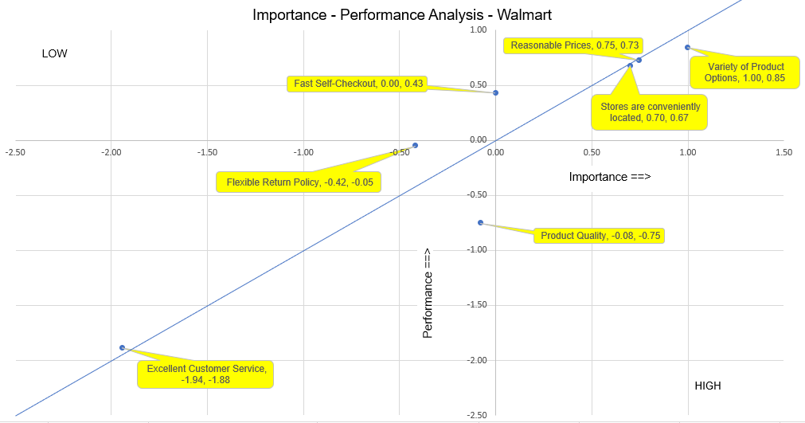**Importance Performance Analysis**

*Walmart*

**Managerial Conclusion:** Walmart has demonstrated commendable performance on the following variables: reasonable prices, convenient location of stores, and variety of product options. As shown in the graph, the Reasonable Prices and Stores are conveniently located variables that are consistently reflected in the operational dynamics of Walmart. However, Walmart needs to improve Product Quality as it is way below the equality line to maintain high standards and meet customer expectations. The Variety of Product Options is very close to the line between Importance and Performance consideration but Walmart needs some effort to address their product quality as it falls far below the line. Walmart needs to prioritize increasing its product quality to increase the levels of customer satisfaction which will improve the brand image so that the company can sustain its competitive edge in the long run of the dynamic retail landscape.

**Importance Performance Analysis**

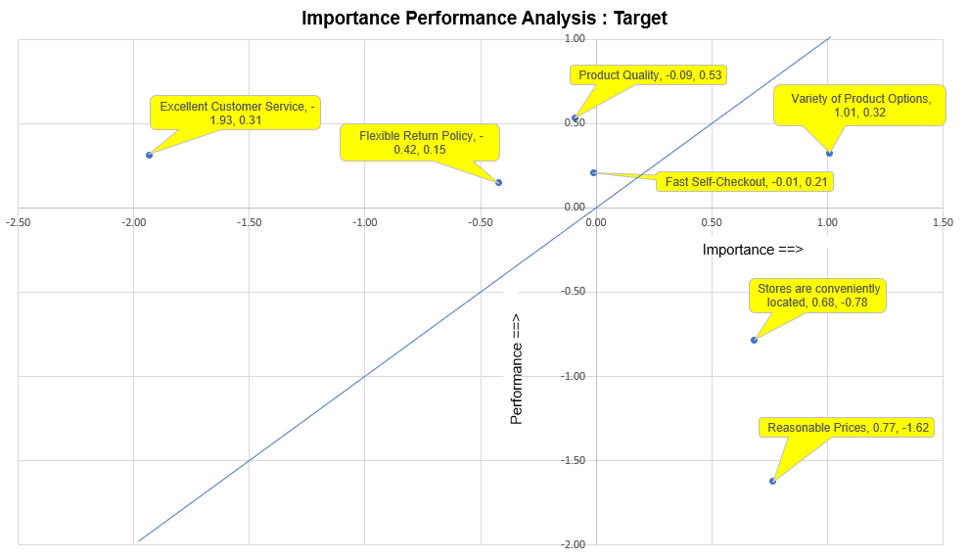*Target*

**Managerial Conclusion:** In contrast to Walmart, Target is performing well in its Product Quality and Fast Self-Checkout. These strengths illustrate Target's commitment to providing superior quality products and efficient service delivery as depicted in the graph. However, there is a considerable gap between customer expectations and operational standards and Target faces areas for improvement, particularly in the Customer Service and Return Policy. Not only that, Target also needs to put a lot of work into improving variables such as Product Options, Store Locations, and Prices as those two variables are way below the line of equality. While Target displays notable strengths in Product Quality and Self-Checkout services, the company should implement Pricing strategies, optimize the Store Locations, and enhance the Product Variety to foster customer loyalty and maintain the profitability of the organization.

**Conclusions**

From the data, we can conclude that although Walmart is performing well in a majority of areas that contribute to overall customer satisfaction, they are still underperforming compared to its main competitor, Target. Across all of our respondents, we see positive perceptions of the store, as many would recommend it to their family members and are frequent shoppers. From our 386 usable responses, it is clear that Walmart is popular because of its conveniently located stores, reasonable prices, variety of product options, fast self-checkout, and flexible return policy. Walmart is known to be a low-cost provider, which many of its competitors cannot compete with. Because of their affordable prices, Walmart is a first-choice shopping option for many low-income customers, large families, or single people. Areas where Walmart is lacking include customer service and product quality. Approximately 13% of respondents disagreed or strongly disagreed that Walmart offered quality products, with an additional 36% of respondents being neutral to the statement. Because Walmart is offering their customers low prices, oftentimes quality can be cut first since higher quality materials cost more. However, Walmart needs their products and offerings to be seen as high quality so they must make a change in their materials usage. Regarding customer service, approximately 35% of respondents disagree or strongly disagree, and 30% are neutral that Walmart offers excellent customer service. Walmart is operating on massive production and sales levels, so customer service might not always be a top priority.

When analyzing our performance data for both Walmart and Target we can see that the male respondents share very similar means in their overall experience for both Walmart and Target. However, the female respondents had a significantly higher mean for their overall experience at Target at 4.10, compared to their overall experience at Walmart at 3.70. We can deduce that women favor the shopping experience at Target, over Walmart, whereas men seemed to feel similarly about both. This demographic data shows Walmart that some of their next steps to improving their shopping experience could be catering specific aspects of it to women. Further investigation could be done into the way the genders perceive a shopping experience, as well as their preference for a shopping experience. As previously mentioned, it is clear that females had more preferences when it pertains to their store of choice and what makes it an enjoyable experience, however, it appears that males see it as something that needs to get done and not a leisurely activity meant for enjoyment.

The Chi-Square test that was conducted for Walmart shows that this relationship is significant at the 0.010 level. We see that about 67.2 percent of males agree or strongly agree that they are regular customers at Walmart, while only 61.1 percent of females do. Correspondingly, about 30 percent of females disagree or strongly disagree that they like the fast self-checkout option at Walmart, while only about 19.4 percent of males do. Overall, there are gender segments in the regularity of customers at Walmart.

The Chi-Square test conducted for Target shows that this relationship is significant at the <0.001 level. We see that about 65.3 percent of females agree or strongly agree that they are regular customers at Target, while only 37.1 percent of males do. Correspondingly, about 47.7 percent of males disagree or strongly disagree that they are regular customers at Target, while only about 25.3 percent of females do. Overall, there are gender segments in the regularity of customers at Target.

When comparing the results of both of our Chi-Square tests we see significant gender disparities in customer regularity. Female respondents shop more consistently at Target than they do at Walmart. Similarly, we can see that male respondents are more regular shoppers at Walmart. These findings highlight the importance of considering gender segmentation in understanding customer preferences and behaviors in retail settings.

When analyzing our performance variables through the demographic of race, we noticed that White or Caucasian respondents have a higher mean for overall satisfaction with their shopping experience at Target compared to Black or African American respondents. On the other hand, Black or African American respondents had a higher mean for overall satisfaction with their shopping experience at Walmart than White or Caucasian respondents. This may suggest that there is a preference of stores between the demographics, further research and analysis may be necessary to uncover the underlying factors contributing to these differences.

Both of the regressions show the following five variables: customer regularity, excellent customer service, variety of product options, high product quality, and possessing a welcoming environment for all customers are highly correlated to customers' overall satisfaction and experience at Walmart. Our correlation proves that Walmart’s managers should greatly consider these variables when making decisions about their stores and the shopping experience they provide.

Our research holds significant implications in addressing the central question of how to improve Walmart customer’s overall shopping experience. By meticulously examining various facets of consumer behavior through our questionnaire and leveraging diverse sampling methods, we have generated meaningful insights that can inform strategic initiatives aimed at improving Walmart’s customer satisfaction and loyalty. The finding not only sheds light on specific areas such as pricing, product options, customer service, and product quality but also provides a nuanced understanding of consumer expectations and preferences. This understanding is instrumental for Walmart and other retailers in tailoring their offerings to meet the evolving needs of their customer base. As these consumer expectations continue to evolve in the retail space, our research serves as a vital resource for Walmart to stay competitive and deliver an enhanced shopping experience that resonates with its diverse customer demographics.

By conducting this research, we can contribute valuable information that recognizes addressable issues within Walmart Incorporated. Despite Walmart having success as a mega-corporation, this does not mean it lacks areas of improvement. All data collected can serve as a positive contribution to Walmart’s next steps in addressing the shortcomings that have been brought to their attention through our research. To remain competitive in the market, Walmart should continue to look into what makes a shopping experience enjoyable and how to incorporate it into their business so that they may remain relevant and competitive.  Our research could also be expanded through the study of the e-commerce shopping experience, e-commerce accessibility, and how the competitive market differs online compared to in-store shopping experiences.

In conclusion, our research underscores the imperative for retailers like Walmart to prioritize customer-centric strategies aimed at enhancing the overall shopping experience. By delving into the intricacies of consumer preferences and perceptions, we have provided actionable insights that can drive meaningful improvements in various aspects of the retail environment. The implications extend beyond Walmart to the broader retail industry, emphasizing the importance of understanding and adapting to changing consumer behaviors and expectations. As the retail landscape continues to evolve amidst technological advancements and shifting consumer trends, our research serves as a reminder of the critical role that customer satisfaction plays in maintaining competitiveness and fostering long-term success. Ultimately, by prioritizing the delivery of exceptional shopping experiences, Walmart can cultivate stronger relationships with its customers, create brand loyalty, and gain more market share in an increasingly competitive marketplace.

**Recommendations**

Because Walmart is underperforming in their customer service, we recommend that Walmart require quarterly training for their employees and provide expectations for them when it comes to interacting with customers. For example, Chick-fil-A is known for its excellent customer service as it is always “their pleasure” to serve customers. While this is an extreme example, Walmart can come up with customer service signatures that they live by and uphold their employees to this standard. Additionally, to incentivize workers to perform better in their customer service offerings, Walmart could take feedback from store surveys and reward the top 10% of stores with the highest customer satisfaction rating.

Walmart is underperforming in its product quality, which is mainly due to its incredibly low prices. Walmart utilizes cheaper materials which is why they can provide low prices to their customers. To combat its reputation of poor product quality, we recommend that Walmart introduce a new brand called Walmart Premium. Walmart is known for its Great Value brand which is usually the most affordable price point on the shelf. However, if they created a middle option that’s in between Great Value and name-brand products then this could potentially increase customer’s perception of their products. While customers could still potentially think that Walmart’s products are cheap, there would be higher quality products available to them, and now it is in the consumer's hand which they would rather have – higher quality or the lowest price point.

Through our data, we found that women prefer shopping at Target much more than at Walmart. Because of this, we recommend that Walmart increase its store’s aesthetics and overall aura if they want to gain more female customers. Preferences for shopping at Target over Walmart, particularly among women, can vary for several reasons including store atmosphere, product selection, products offered, and product quality. Target's stores are typically cleaner, better organized, and aesthetically pleasing, which can make the shopping experience more enjoyable for some women. Additionally, Target tends to carry a wider variety of products compared to Walmart, especially in categories like home decor, clothing, and beauty which better fits their tastes as opposed to men. To compete better, we recommend that Walmart improve the cleanliness, organization, and overall aesthetics of their stores, so that they can create a more pleasant shopping experience for female customers. This includes maintaining well-lit aisles, clear signage, and attractive displays.

Our Chi-Square Test concluded that there are gender segments in the regularity of customers at Walmart. As stated in the paragraph above, women prefer Target, and men prefer Walmart. We continue to recommend that Walmart place more attractive displays in stores, partner with brands to make more desirable products, and overall increase the cleanliness of their stores so that women enjoy their experience more.

Regarding race, we saw slight racial segments with white or Caucasian respondents having a higher mean for overall satisfaction with their shopping experience at Target compared to black or African American respondents. We recommend that Walmart seek to dive into further investigation on this information, as well as continue to provide a welcoming atmosphere for individuals of all racial ethnicities.

The results of our regression analysis showed that the following five variables: customer regularity, excellent customer service, variety of product options, high product quality, and possessing a welcoming environment for all customers are highly correlated to customers' overall satisfaction and experience at Walmart. Because of this, we recommend that Walmart create a survey for customers to complete with these five variables as the main questions. Because these five variables are so highly correlated, if Walmart can see which areas they need to improve on, then they will have an increased rate of overall customer satisfaction.

**Limitations**

1. Lack of literature review / secondary research (see further explanation below)

“A literature search allows the researcher to better design their study, identify appropriate methodology, and ensure that the technique of analysis is best beneficial for the sample. To create research that is meaningful and well-focused, literature searches allow for a better foundation of knowledge and relevance for the researcher’s findings.” (Source: **National Library of Medicine**)

Secondary research generally takes less time and costs less money than primary research, so we should use it whenever we can. Additionally, we can learn about the topic of research in detail before completing our work which provides a better overall understanding.

We did not complete a literature search because of the time constraint of completing this research in a single semester.

1. Not using a random sample (see further explanation below). Despite no random sampling, the test of one proportion shows that the percentage of females in the sample is consistent with the population percentage.

A probability sample is the better way of sampling because we know the precise probability of any one person being selected for our sample. However, we did a convenience sample, which is one example of a **non-probability** sample.

We did not do a random sample because of a lack of time and resources. We had the time constraint of completing this research in a single semester. A convenience sample is much quicker and much more convenient to do so.

While it is much quicker, the disadvantages include:

a. Less generalizability to the population.

b. Related to the above point, such a sample is self-selected, which means that the people we asked decided whether to participate or not. We can't tell if, for example, Amazon got a higher rating because it is highly regarded or because those who thought highly of it were more likely to respond.

c. Bias in the sample

1. Results of Test of One Proportion

A test of one proportion (p. 35) indicates that the proportion of females in our sample is consistent with that of the UWG population. While we did not set out to interview mainly college students, we found that about 60 percent of our sample was indeed of college age. This at least partially justifies our use of college population data. This ameliorates our second limitation.

1. Lack of Time

To conduct better research, we would ideally want to collect more responses over a longer period. Because this class is only one semester long, we were under a strict time constraint and therefore collected approximately 386 responses.

1. Methodology Bias

Reflecting on the methodology employed in our research, one of our strengths was our comprehensive questionnaire design that covered a wide range of aspects that pertain to the Walmart shopping experience. We had a diverse sampling method by distributing the survey through several channels like email, text, and social media, allowing us to gain a wide variety of consumer opinions. Lastly, we were able to efficiently administer the survey through the use of Qualtrics, allowing us to streamline the data collection process.

Areas of improvement of our methodology include sampling bias that could have occurred despite our efforts to have diverse data. This is because our team is drawing from personal networks and academic affiliations, many of which we share. There is also always the chance of bias in self-reported data, participants may respond due to skewed memories or societal pressure which may lead to inaccurate data collection. Finally, to keep things simple we had a limited scope of demographic questions like age, race, gender, and annual household income. However, additional demographic questions could have provided further insight into our consumer behavior and preferences, allowing for more detailed data.

Challenges that we encountered during the research process primarily pertained to ensuring we were receiving consistent and valid responses. Referring to the weakness in our methodology, it can be extremely difficult to ensure you are receiving 100% accurate responses when your survey requires self-reporting, therefore it was important for the team to continuously check our response and accuracy rate. This allowed us to flag incomplete or inaccurate survey responses.

**Appendix**

1. Questionnaire

Walmart Questionnaire (MKTG 6850)

Disclaimer   
The questionnaire used here is for a class project in MKTG 6850. The insights will help us (students) come to conclusions about products and services aiming to enhance consumer satisfaction. It is a confidential survey, and no personal details will be disclosed -- only aggregated data will be used. Yet, if any part of this study is bothersome to you, you may decline to answer that/those question(s) or decline to respond to this survey entirely. Thank You for Your Cooperation.

Q1 What is your gender?

* Male (1)
* Female (2)
* Other: (3) __________________________________________________
* Prefer not to say (4)

Q2 What terms would you use to express your race or ethnicity?

* American Indian or Alaska Native (1)
* Asian (2)
* Black or African American (3)
* Native Hawaiian or Pacific Islander (4)
* White (5)
* Others: (6) __________________________________________________

|  |
| --- |
|  |

Q3 What is your approximate age? (Please enter a whole number close to your current age without decimal places)

________________________________________________________________

|  |
| --- |
|  |

Q4 What is your approximate annual household income? (Please enter a whole number without decimal places, $ signs, or commas)

________________________________________________________________

Q5 How do you prefer shopping at Walmart?

* Predominantly In-person (1)
* Predominantly Online (2)
* Both In-person and Online (3)

|  |
| --- |
|  |

Q6 Approximately how much do you spend on shopping at Walmart per month? (Please enter a whole number without decimal places, $ signs, or commas)

________________________________________________________________

|  |
| --- |
|  |

Q7 What is the approximate distance from your location to the nearest Walmart store (in miles)? (Please enter a whole number without decimal places)

________________________________________________________________

Q8 Please indicate the extent of your agreement or disagreement.

|  |  |  |  |  |  |
| --- | --- | --- | --- | --- | --- |
|  | Strongly disagree (1) | Disagree (2) | Neither agree nor disagree (3) | Agree (4) | Strongly agree (5) |
| Walmart has a welcoming environment for all consumers. (1) |  |  |  |  |  |

Q9 Please indicate the extent of your agreement or disagreement.

|  |  |  |  |  |  |
| --- | --- | --- | --- | --- | --- |
|  | Strongly disagree (1) | Disagree (2) | Neither agree nor disagree (3) | Agree (4) | Strongly agree (5) |
| Walmart has an easy curbside pick-up process. (1) |  |  |  |  |  |

Q10 Please indicate the extent of your agreement or disagreement.

|  |  |  |  |  |  |
| --- | --- | --- | --- | --- | --- |
|  | Strongly disagree (1) | Disagree (2) | Neither agree nor disagree (3) | Agree (4) | Strongly agree (5) |
| Walmart has a seamless online shopping experience. (1) |  |  |  |  |  |

Q11 Please indicate the extent of your agreement or disagreement.

|  |  |  |  |  |  |
| --- | --- | --- | --- | --- | --- |
|  | Strongly disagree (1) | Disagree (2) | Neither agree nor disagree (3) | Agree (4) | Strongly agree (5) |
| Walmart is well-known for its private label brand like Great Value at competitive prices. (1) |  |  |  |  |  |

Q12 This question is not a rating of a specific store but seeks to determine how **important** each of the following attributes is when you decide what store to frequent. Please indicate the extent of your agreement or disagreement with how **important** each item is to you in your decision to frequent a store.

|  |  |  |  |  |  |
| --- | --- | --- | --- | --- | --- |
|  | Strongly disagree (6) | Disagree (7) | Neither agree nor disagree (8) | Agree (9) | Strongly agree (10) |
| Fast Self-Checkout (1) |  |  |  |  |  |
| Variety of Product Options (2) |  |  |  |  |  |
| Stores are conveniently located (3) |  |  |  |  |  |
| Reasonable Prices (4) |  |  |  |  |  |
| Excellent Customer Service (5) |  |  |  |  |  |
| Product Quality (6) |  |  |  |  |  |
| Flexible Return Policy (7) |  |  |  |  |  |

Q13 Please indicate the extent of your agreement or disagreement of each statement about Walmart.

|  |  |  |  |  |  |
| --- | --- | --- | --- | --- | --- |
|  | Strongly disagree (6) | Disagree (7) | Neither agree nor disagree (8) | Agree (9) | Strongly agree (10) |
| I am a regular customer at Walmart (1) |  |  |  |  |  |
| I like the fast self–checkout option at Walmart (2) |  |  |  |  |  |
| Offers a variety of product options (3) |  |  |  |  |  |
| Has more convenient locations for me (4) |  |  |  |  |  |
| Offers products at Reasonable Prices (5) |  |  |  |  |  |
| Has Excellent Customer Service (6) |  |  |  |  |  |
| Has High Product Quality (7) |  |  |  |  |  |
| Has a flexible return policy (8) |  |  |  |  |  |
| I am satisfied with the Overall Experience (9) |  |  |  |  |  |
| I am likely to recommend Walmart to family and friends. (10) |  |  |  |  |  |

Q14 Please indicate the extent of your agreement or disagreement of each statement about Target.

|  |  |  |  |  |  |
| --- | --- | --- | --- | --- | --- |
|  | Strongly disagree (6) | Disagree (7) | Neither agree nor disagree (8) | Agree (9) | Strongly agree (10) |
| I am a regular customer at Target (1) |  |  |  |  |  |
| I like the fast self–checkout option at Target (2) |  |  |  |  |  |
| Offers a variety of product options (3) |  |  |  |  |  |
| Has more convenient locations for me (4) |  |  |  |  |  |
| Offers products at Reasonable Prices (5) |  |  |  |  |  |
| Has Excellent Customer Service (6) |  |  |  |  |  |
| Has High Product Quality (7) |  |  |  |  |  |
| Has a flexible return policy (8) |  |  |  |  |  |
| I am satisfied with the Overall Experience (9) |  |  |  |  |  |
| I am likely to recommend Target to family and friends. (10) |  |  |  |  |  |